Indiana Division of Disability and Rehabilitative Services

Vocational Rehabilitation Claim Payment System
Claiming User Guide

November 2020

Table of Contents
Introduction 5
Note on screenshots 5
Dashboards 5
Vendor Dashboard 5
Business Scenario 5
State Dashboard 6
Business Scenario 7
How to View an Authorization 8
Authorization Information 11
Export Functionality 11
How to Enter a Claim 12
Method 1 12
Method 2 12
Adding Line Items to a Claim 14
Business Scenario 14
Adding Multiple Claim Items to the Same Claim 17
Business Scenario 17
Adding CPT Codes to a Claim Item 18
Business Scenario 18
Removing a CPT code 20
Business Scenario 20
Saving a CPT code 20
Returning to Claim Information 21
Removing a Claim Item 21
Business Scenario 21
Adding Additional Information to a Claim 22
Business Scenario 22
How to Attach a Supporting Document 23
How to Search for a Claim 25
Business Scenario 25
Claim Statuses 28
Finding Information and Reporting 29
Participant Lookup 29
Business Scenario 29
Accessing Participant Details (Multi-tabbed) 31
Participant Info Tab 31
Authorizations Tab 32
Claims Tab 32
Payments 33
View Checks 33
Business Scenario 33
Viewing Payment Details 34
State Users Only: Finding Information and Reporting 35
Invoicing Details 35
Business Scenario 35
Batch Checks 36
Business Scenario 36
Reports 37
User Statistics 37
Business Scenario 37
Payments by Procedure Code 38
Business Scenario 38
Authorization Research 39
Business Scenario 39
Claim Status 40
Business Scenario 40
Outstanding Authorizations 41
Business Scenario 41
Vendor Payments by Client and Claim Detail 42
Business Scenario 42
Appendix A 44
A.1 Report Navigation Bar 44
Appendix B 46
B.1 Roles Matrix 46
Appendix C 47
C.1 Acronym List 47
Appendix D 48
C.2 Service Types Matrix 48
Appendix E 51
Important Points 51

Introduction
The Division of Disability and Rehabilitation Services, Bureau of Rehabilitation Services has contracted with Public Consulting Group (PCG) to implement an electronic Claim Payment System (CPS) for Vocational Rehabilitation (VR) service vendors for the submission of invoices and payment of claims.

- All VR Vendors, Participants, Guardians, individuals, and VR Staff must enter claims of an authorization no later than 90 days of the claim end date.
- All claims submitted are reviewed by VR State Staff.
- Only authorized State Users can delete or remove a claim created by another User.

Note on screenshots
The screenshots used in this User guide may depict features and functions that vary depending on the User’s role.

Dashboards
The VR-CPS Dashboard is based on the User type. All State Users have the same dashboard where they can see Vendor registration statuses, authorizations, and claims.
Vendors can only see information for participants they are authorized to serve; this includes authorizations and claims.

Vendor Dashboard-(NOTICE: changes as of December 2020 release)
For Vendor Super Users and Vendor Sub Users, the Vendor Dashboard includes Authorizations, claims in a Not Approved and Draft status that require action and a summary that displays new authorizations in the last 7 days, the number of outstanding authorizations, the last payment information and the number of claims for each status broken down (Draft, Submitted, Approved, Not Approved and Paid).

Business Scenario
Step / Action
- Vendors navigation: Select/Click Home at any time to access the dashboard (shown below).

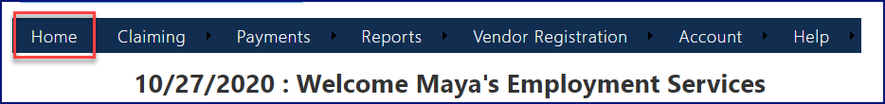

The Authorizations section shown below displays the vendor’s authorizations. Clicking on an authorization number takes the User to the Authorization Information form (screen).

The Claims Not Approved section shown below displays the most recent 100 claims in a not approved status. Once claim is fixed and resubmitted it will move to new location.

The Claims in Draft section shown below displays claims being worked on but not yet submitted.

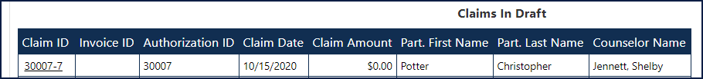

State Dashboard
The State Dashboard offers a comprehensive view of pending and finalized claims through the Indiana Vocational Rehabilitation (VR) Claim Payment System (CPS) web portal. State Users can view Vendor Registration, Authorizations, and Claims in a pending and finalized status.

Business Scenario
Step / Action

- To access the State Dashboard while logged in as a State User, Select/Click Home from any screen.

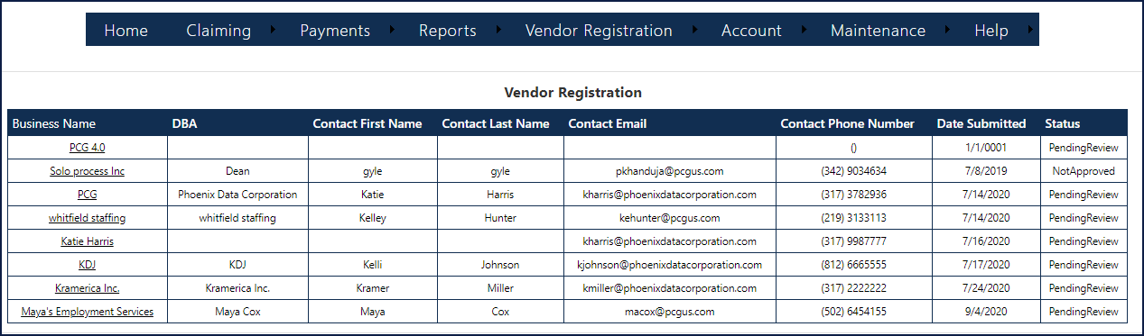

The Vendor Registration section shown below displays vendor registration requests that are not approved or are pending.

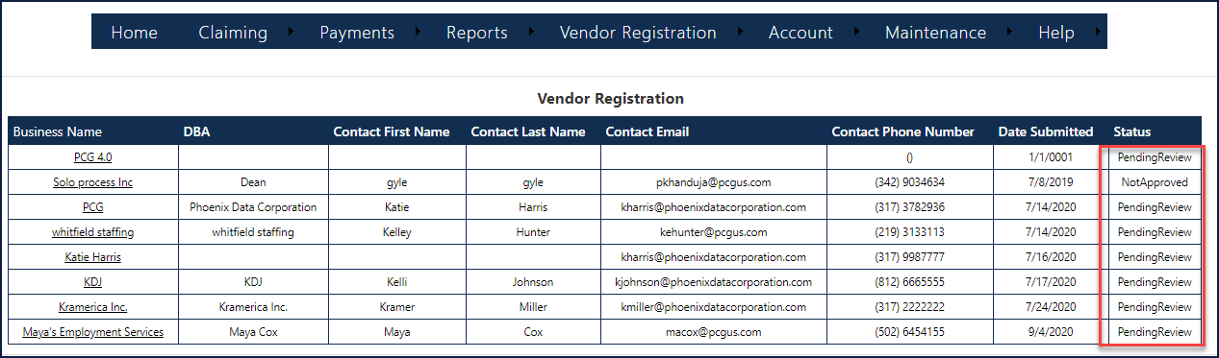

The Authorizations section shown below displays the most recent 100 authorizations.
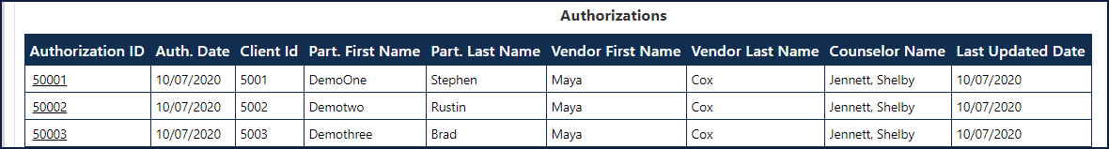

The Claims section shown below displays the most recent 100 claims draft and not approved status.

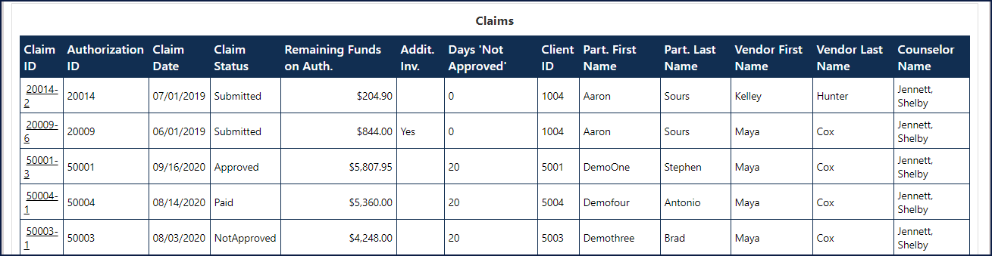

How to View an Authorization
Step / Action

- Select/Click Claiming. You can also view authorizations by going to the ‘Participant Lookup’ tab.
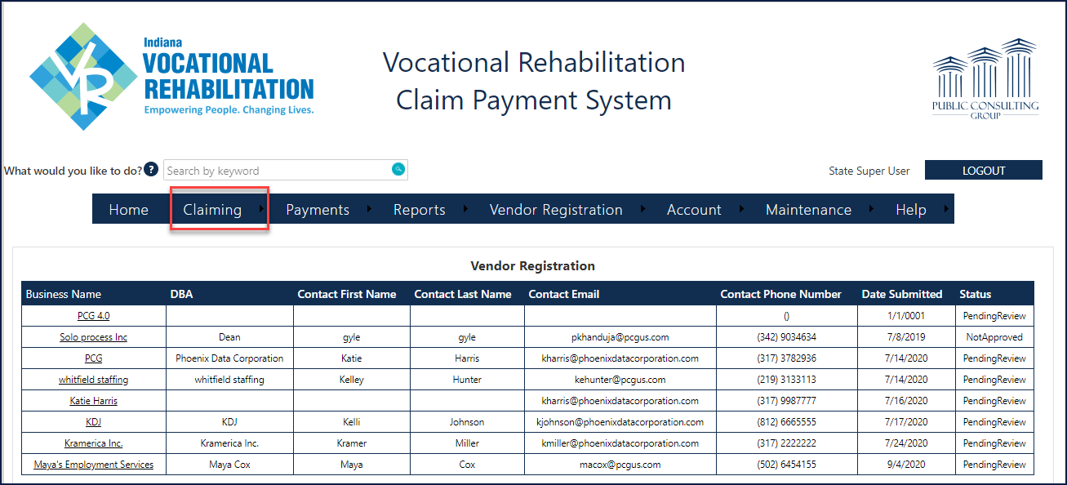

- Select/Click on Authorization Search or Participant Lookup.

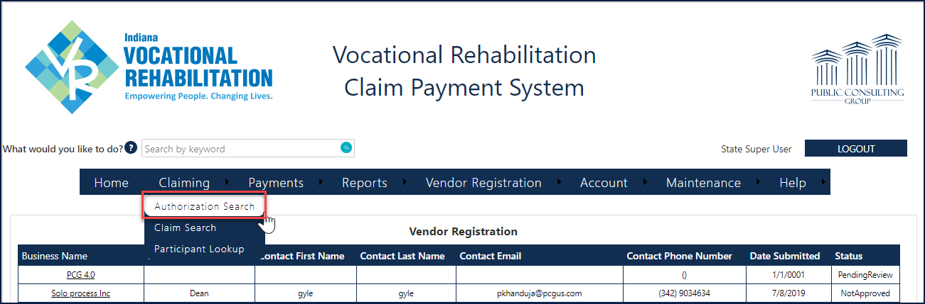

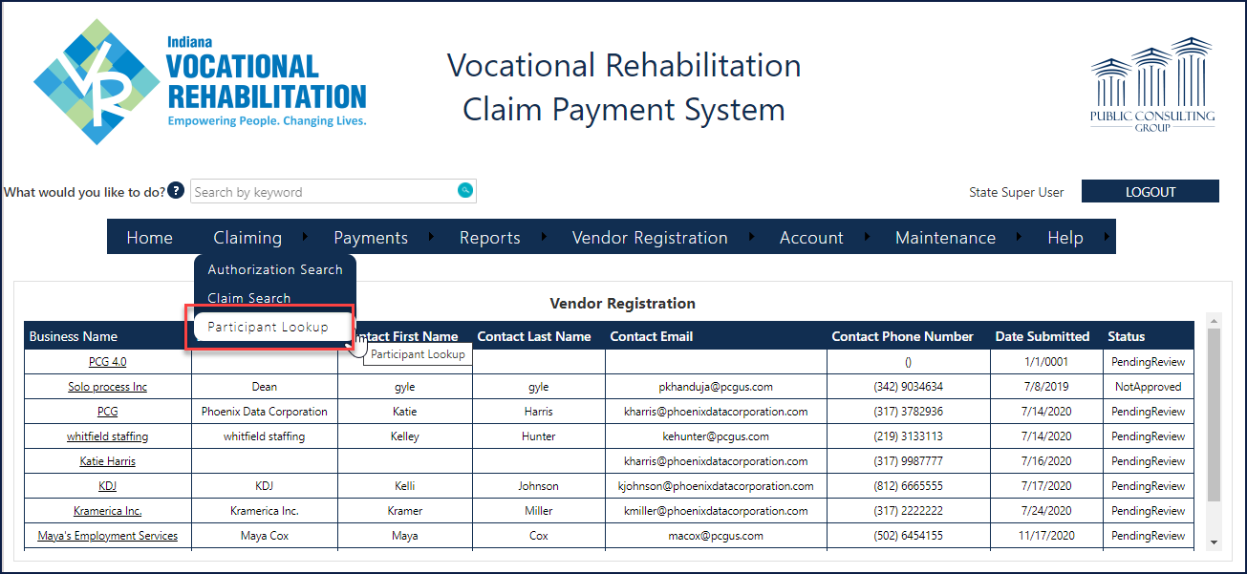

- Users can enter information in one of the following Auth Number, Vendor/Address, Authorization Created Date, Participant/Client ID, Authorization Begin Date, Authorization End Date, and Remaining Funds fields.

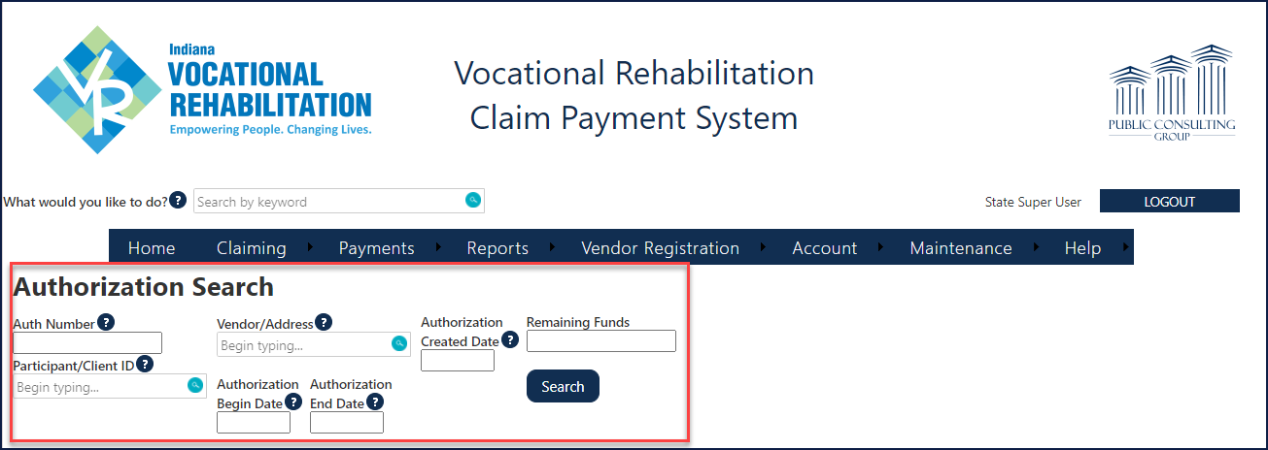

- Next, click Search.
Authorization “Begin Date” and “End Date” must be within the authorization start and end date range.
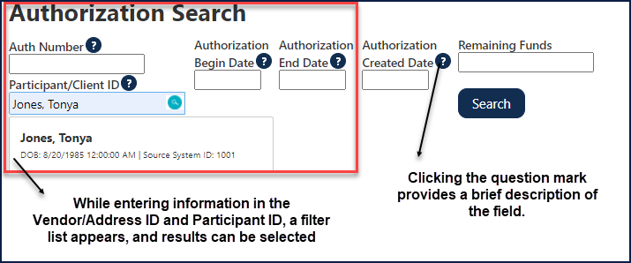

Authorization Search: The Vendor name always take precedence when selecting Vendor/Address Field. The address will populate when the User has a minimum of two words.

The Authorization spreadsheet/grid shown below, displays the User's results.

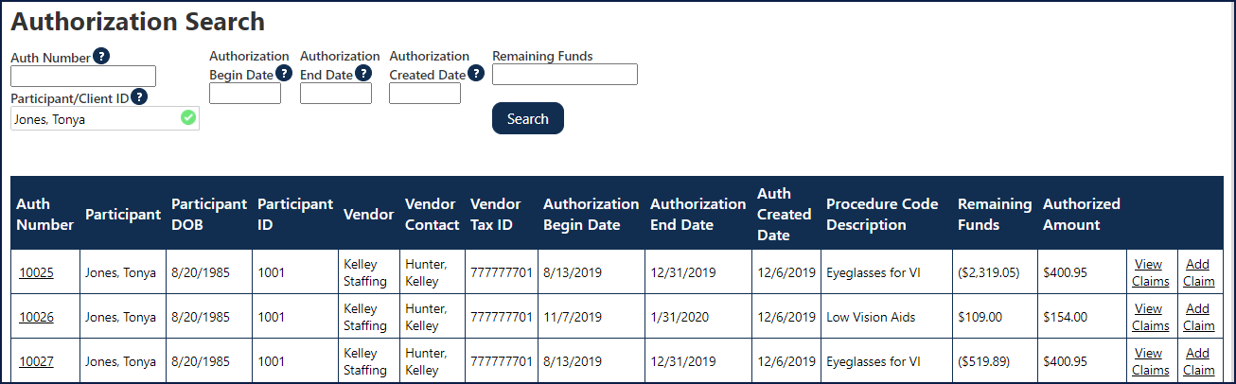

- Click on the Auth Number hyperlink (shown below).

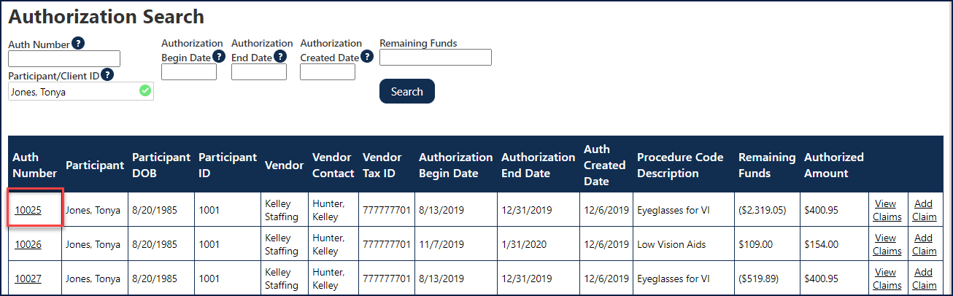

The Authorization Information form (screen) appears displaying detail information on the authorization claim (shown in the next section).

Authorization Information
The Authorization Information form (screen) allows Vendors to view the services/goods they are authorized to provide for a particular participant.

At a high level, the Authorization Information includes:
- Vendor Information
- Participant Information
- Authorization Information
- Authorized Services & Goods
- Authorized Dates, Rates, and Quantity
- State Approvals & Contact Information
- Other Information

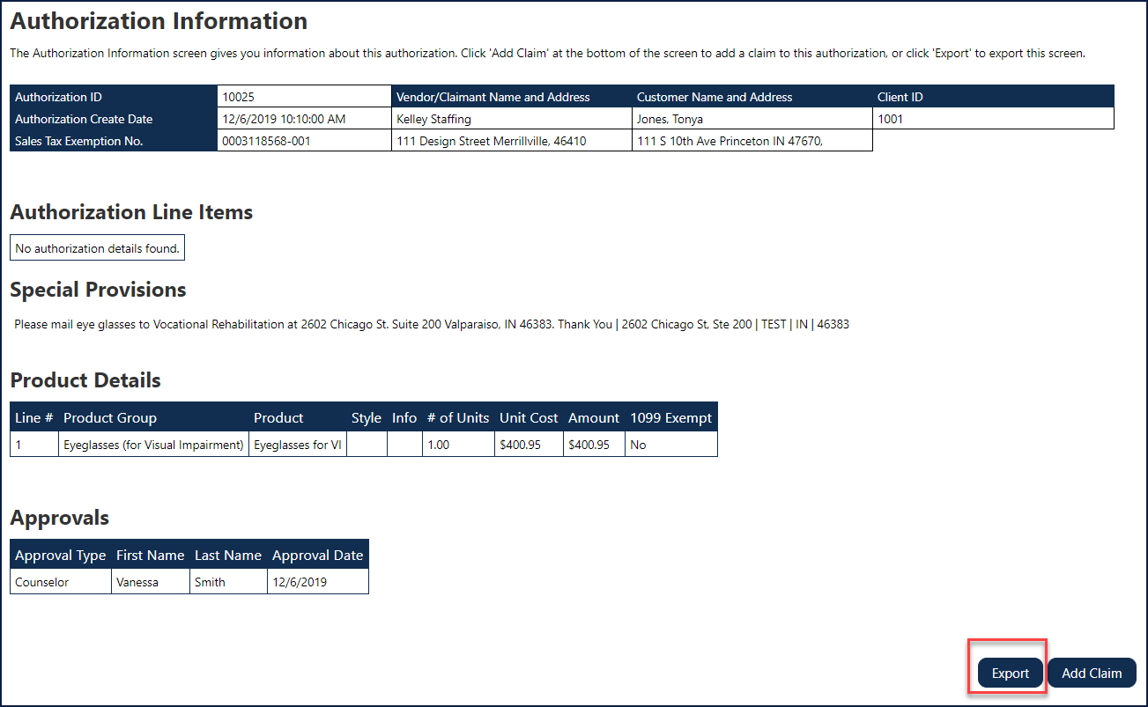

How to Enter a Claim
Users can add a claim to an authorization using one of two methods, described below.
- Users can add multiple claims for authorization, but a claim can only belong to one authorization.
- Claims can be added to an authorization until funds are expended or remaining funds equal zero (0).
Users can also enter the Invoice Number for vendor-specific data. This amount will not be calculated to the Service/Product Rate on the claim unless exceptions apply with CPT Codes (explained in later sections of this document).
  - Note, use the Invoice Number field if Vendors would like to track their bill rates for the particular service/product provided.
The “Invoice Number” field is Vendor specific data that the User can enter for identifying purposes

Method 1
Step / Action
- From the Authorization Search form (screen), select/click Add Claim hyperlink for the correct Auth Number line.

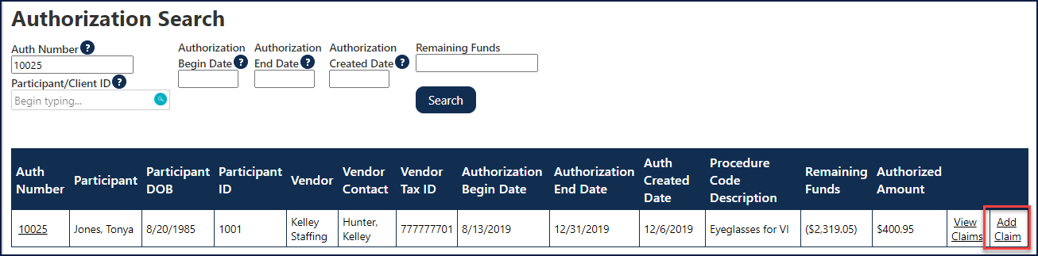

Method 2
Step / Action

- From the Authorization Information form (screen), click the Add Claim button (shown below).

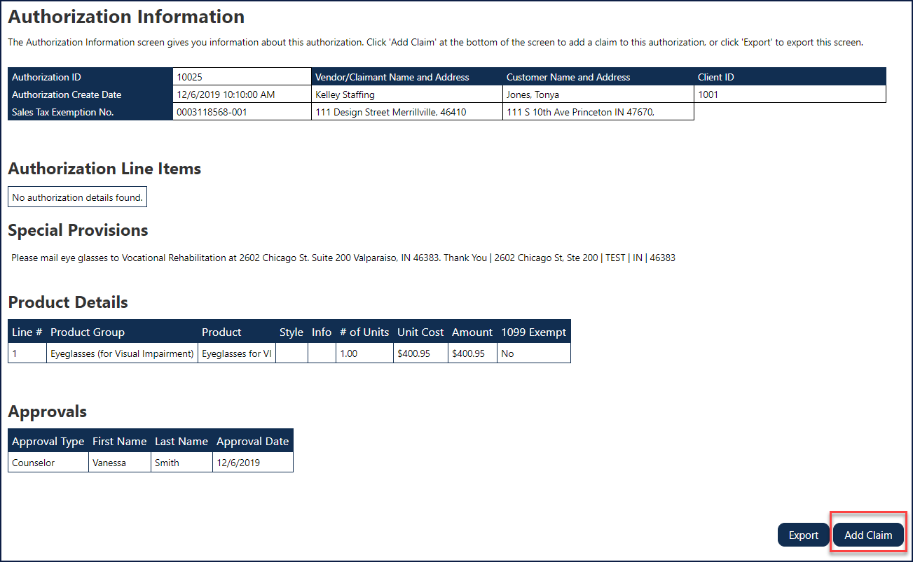

Using either method (mentioned above) shows the Claim Information form (screen). Shown below (unsaved claim), the claim is not saved. The claim is saved once a Claim Number is populated and the Claim Status is set to “Draft.”

Method 3
Step / Action

- From the Participant Lookup form (screen), click the Add Claim button (shown below).
- Enter Participant First and Last Name, Client ID or Authorization number, select ‘Search’.

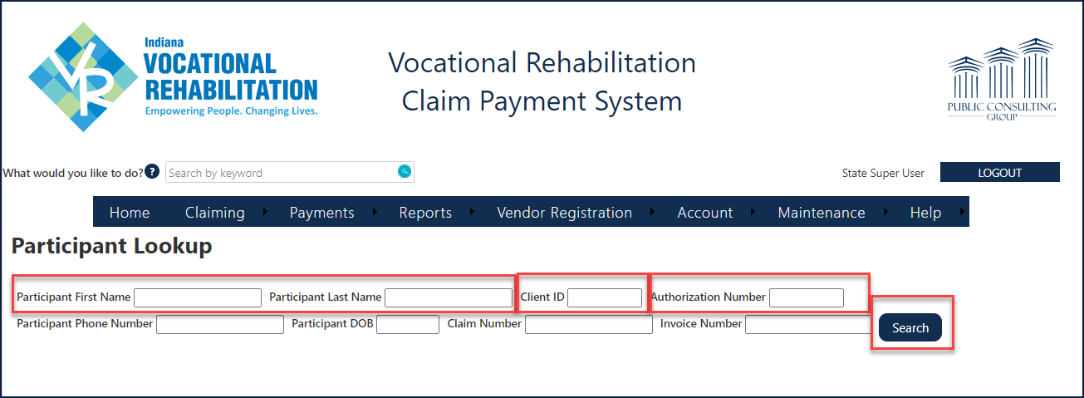

- Select ‘Details’ for additional information.

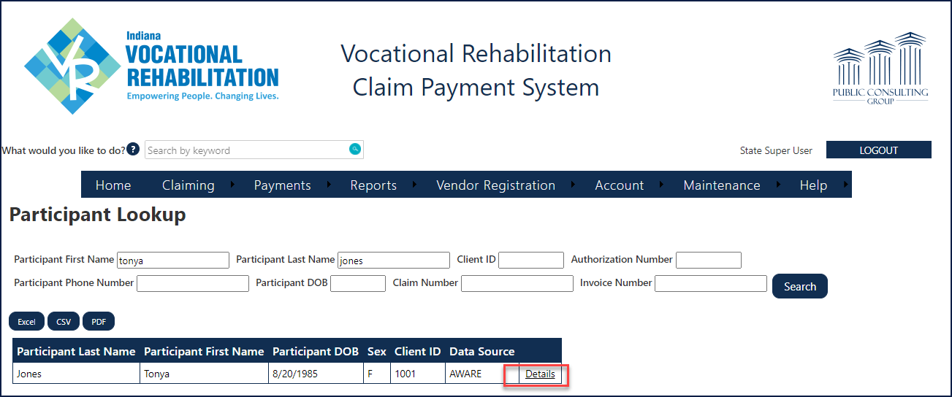

- Select the Authorizations tab and click on the necessary hyperlink to add the claim.

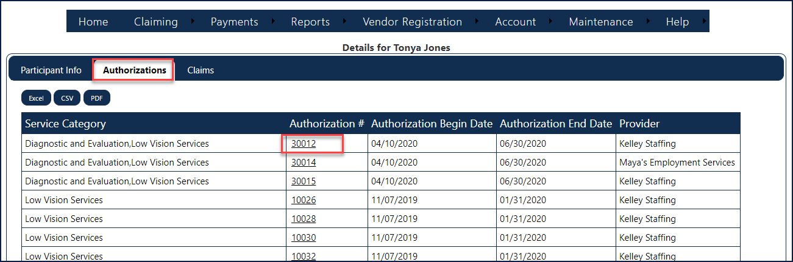

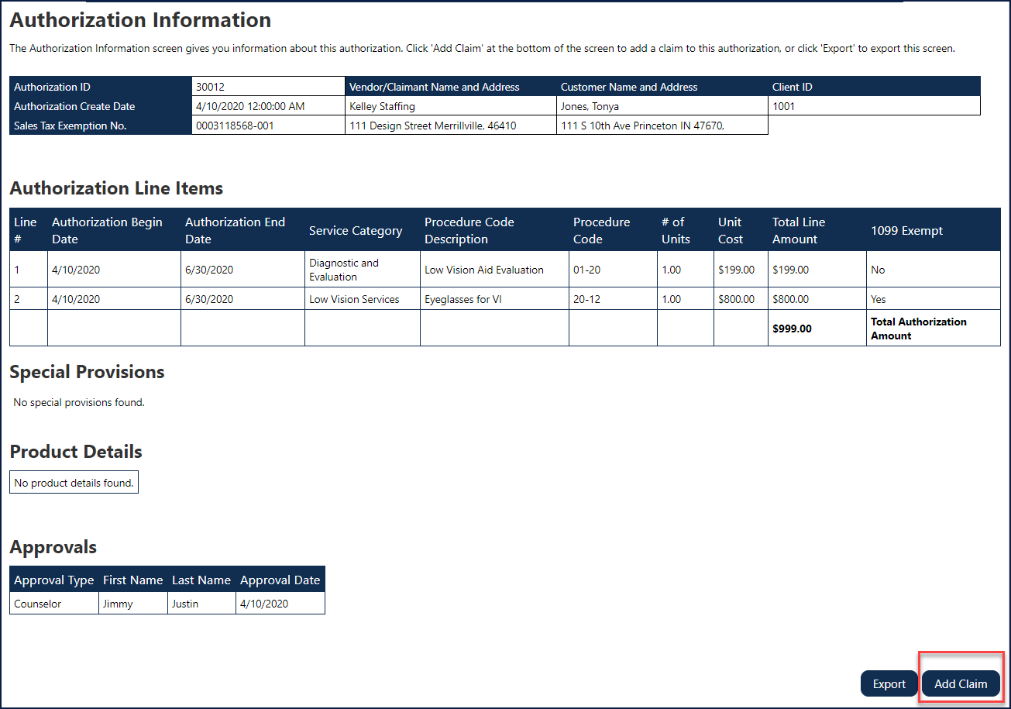

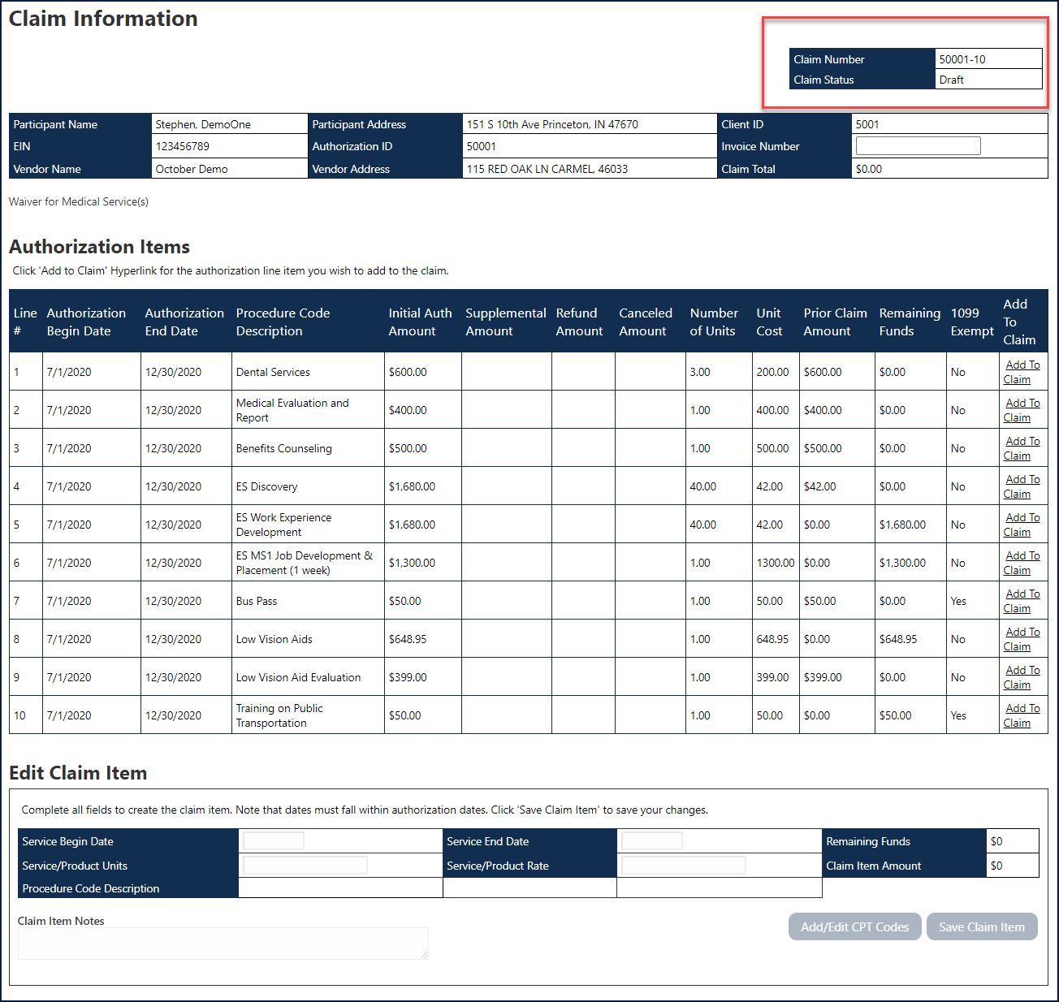

Adding Line Items to a Claim

Business Scenario

From the Claim Information form (screen), Users can add authorization line items to the claim (shown below).

Step / Action
- Click Add To Claim listed in the correct Authorization Item Line #.

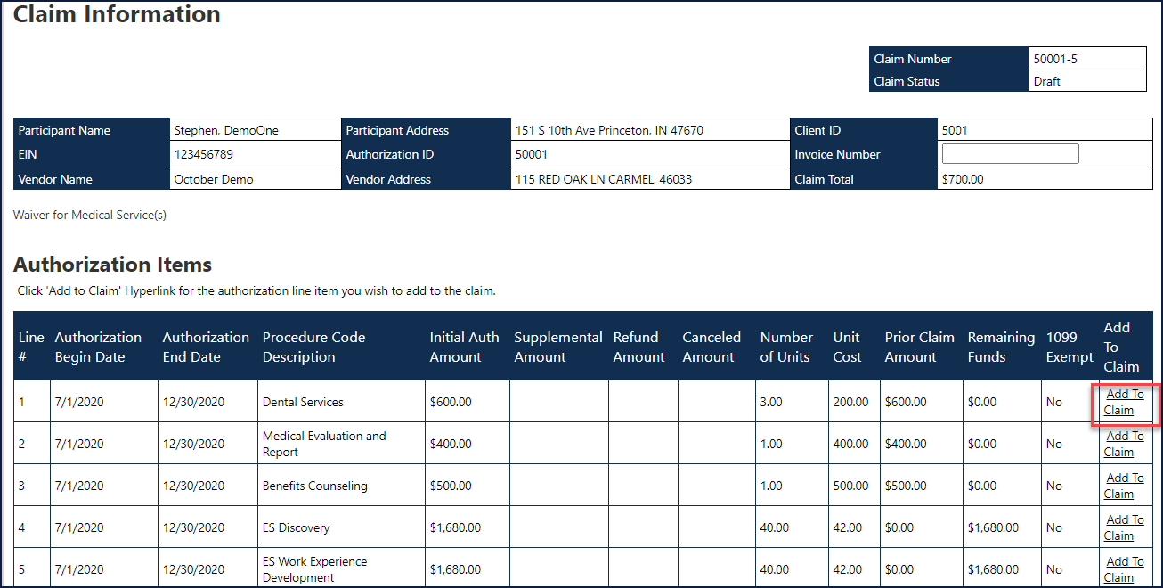

- Enter Service Begin Date and Service End Date.
  - Note the Service Begin and End Date must be within the authorized service dates unless the claim is for tuition or related fees.
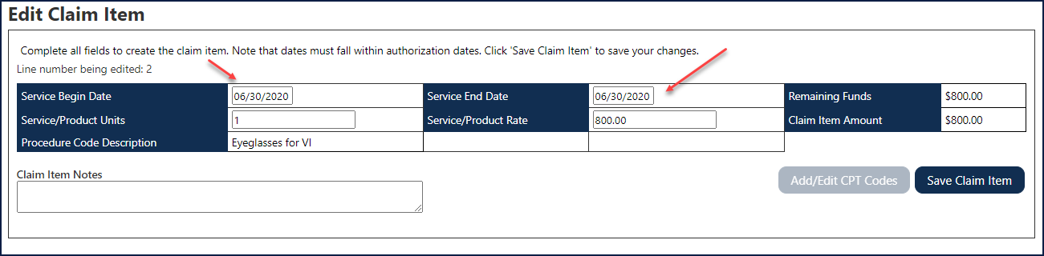

- Users can also add Claim Item Notes (shown below).
  - Note, if a User enters multiple claims that overlap in service dates (service begin and end date), an explanation is required in this field.
  - Note, this is where the vendor can enter notes for the VR state staff to see regarding the specific line items.
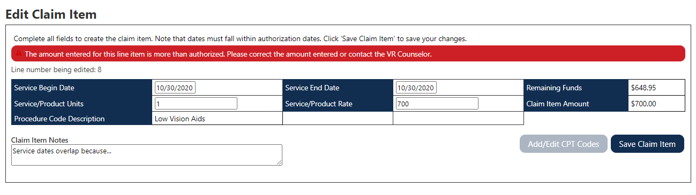

Once a User clicks the Save Claim Item button, the Current Claim Details section populates.
- Note, Users are alerted if there are any errors/messages for the claim item (shown below).
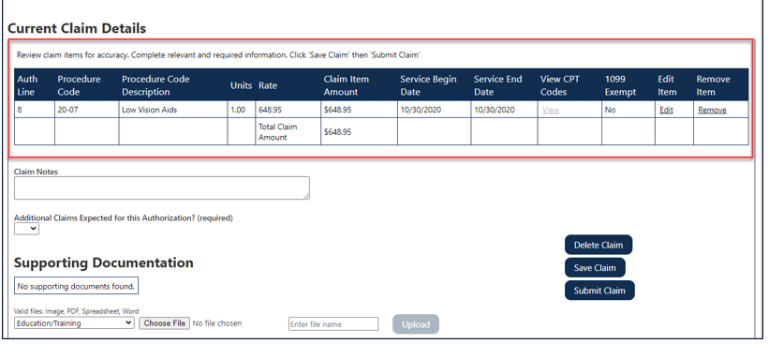

Once the claim item passes the system's fiscal validation rules, the Claim Items section populates. At this point, the claim automatically is saved, and the claim status and claim number populate (shown below).

The Edit Claim Item grid is not populated until a User “edits” an existing claim item or adds another authorization item to the claim.

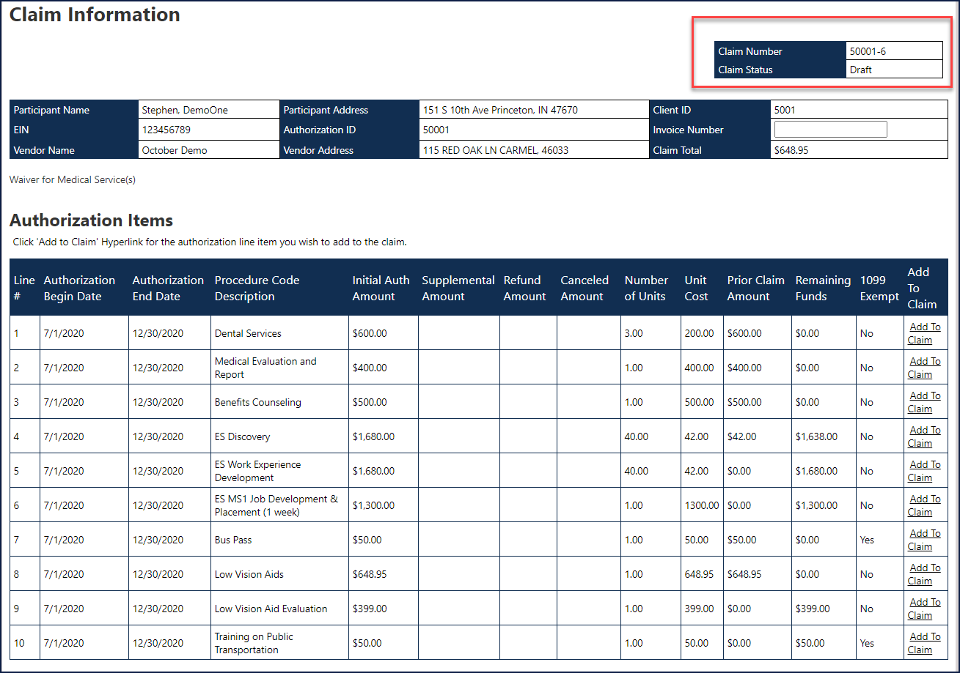

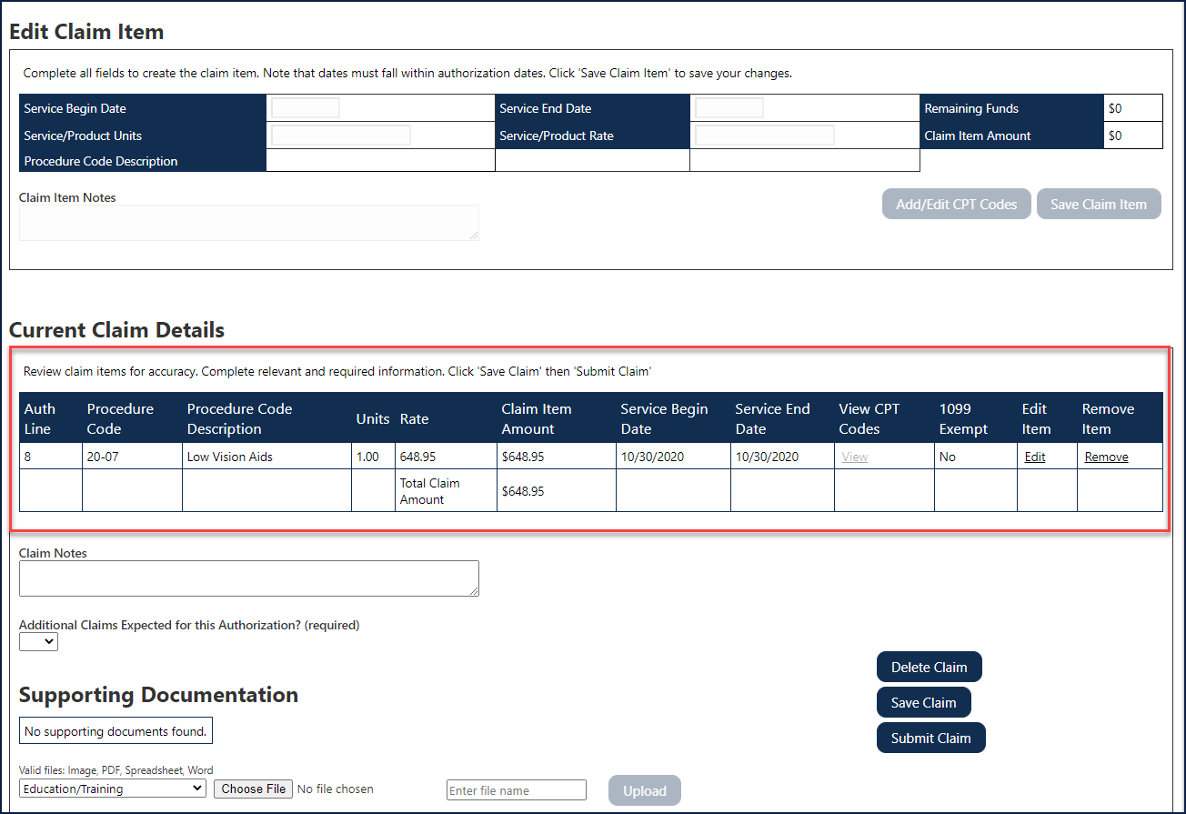

Adding Multiple Claim Items to the Same Claim

Business Scenario

Users can continue selecting/clicking authorization line items to add to a claim. Follow the same process outlined above to complete this.

Step / Action
- Continue selecting Add to Claim hyperlink(s), until all claim items are added to a claim.
- Click the Save Claim Item button beneath the Edit Claim item grid.

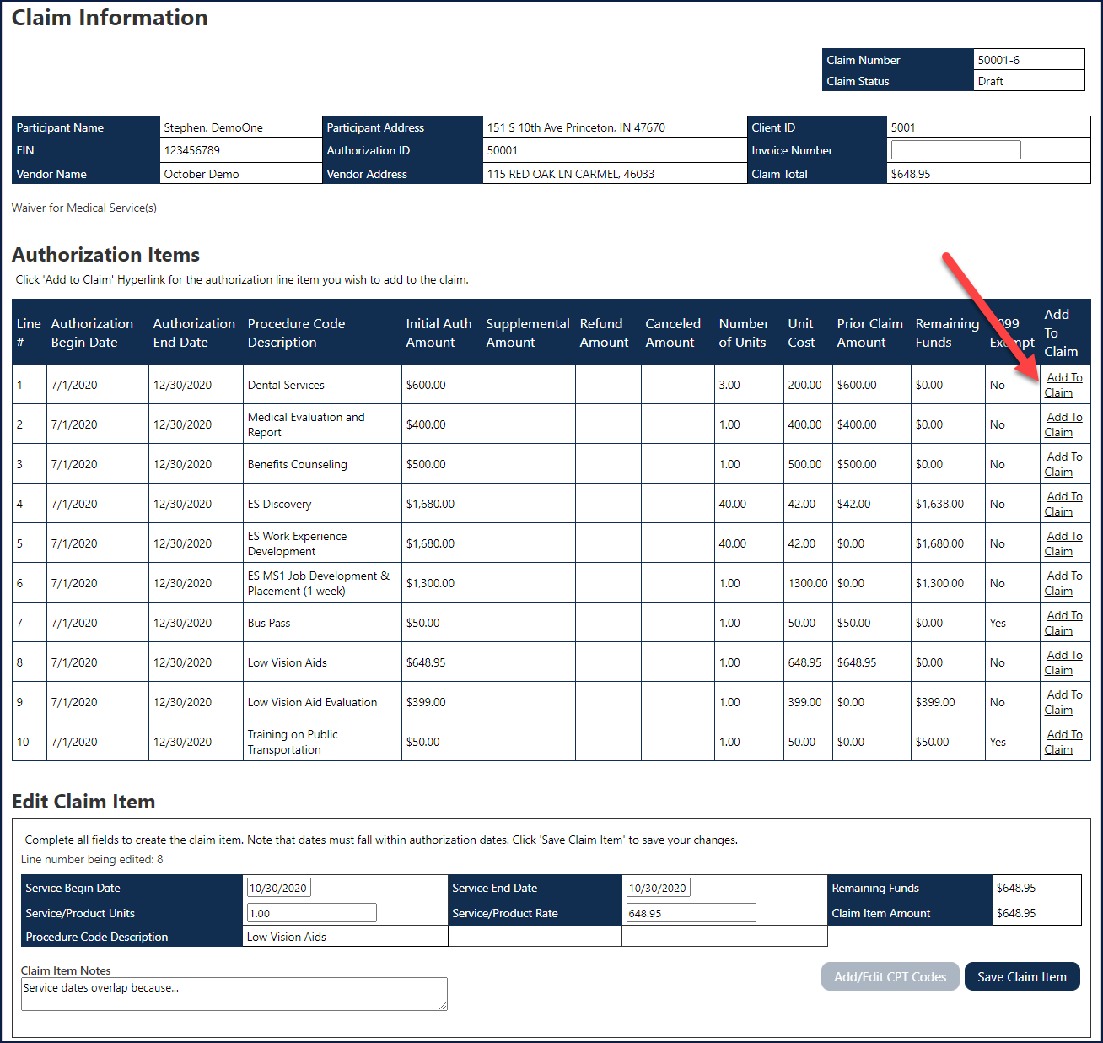

At this point, a Claim is saved in CPS and not submitted to the case management system.
Adding claim items and clicking “Save Claim Item” does not submit a claim for state review.

Adding CPT Codes to a Claim Item
Users can add an unlimited number of CPT codes to a claim item.

Business Scenario

Step / Action
- Click the Add/Edit CPT Codes button (shown below).

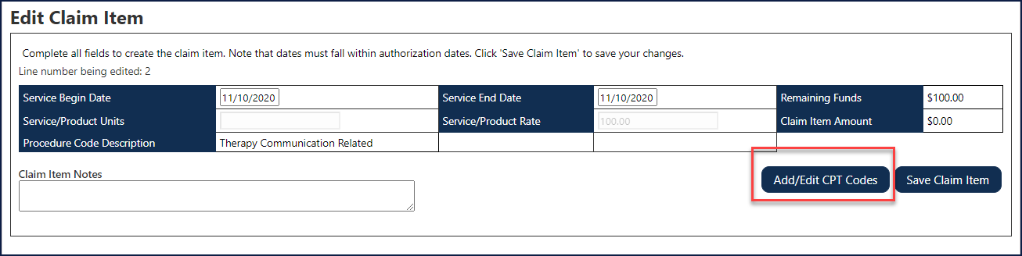

- If the claim item is already saved, click the View hyperlink under View CPT Codes in the Current Claim Details spreadsheet/grid (shown below).

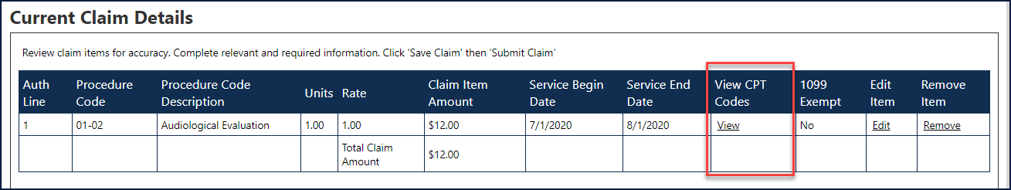

In both methods (mentioned above), the Claim Items – CPT Codes form (screen) displays (shown below). CPT codes added will populate in either CPT Code with Associated Rates or CPT Codes with a $0 Rate. Below the $0 Rate section, users can add items with NO Corresponding CPT Codes. The Total Invoice Amount section will auto-populate from the tables above.

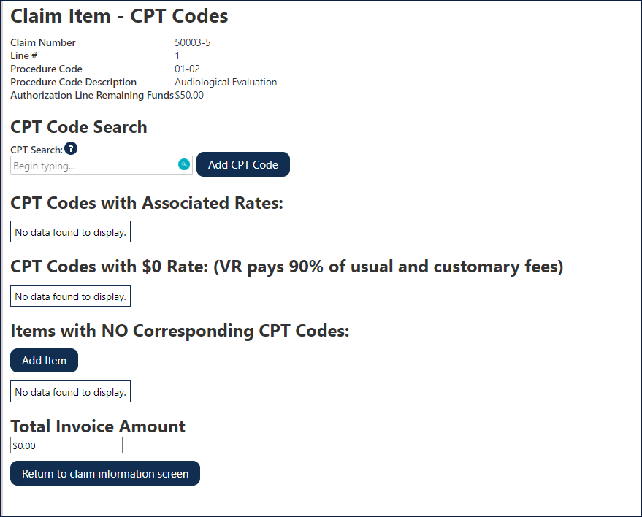

Typing the CPT code in the “CPT Search” field, a list of the most current CPT codes and rates appear (shown below).

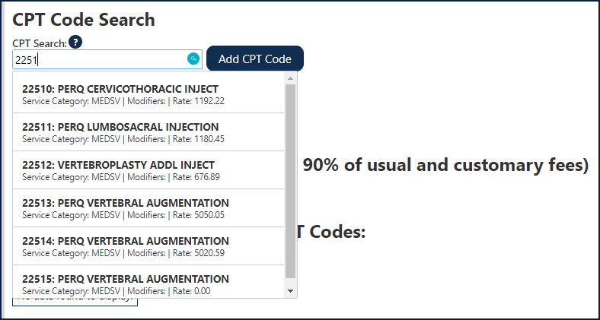

Users can also select the CPT code from the pre-populated list (shown above).

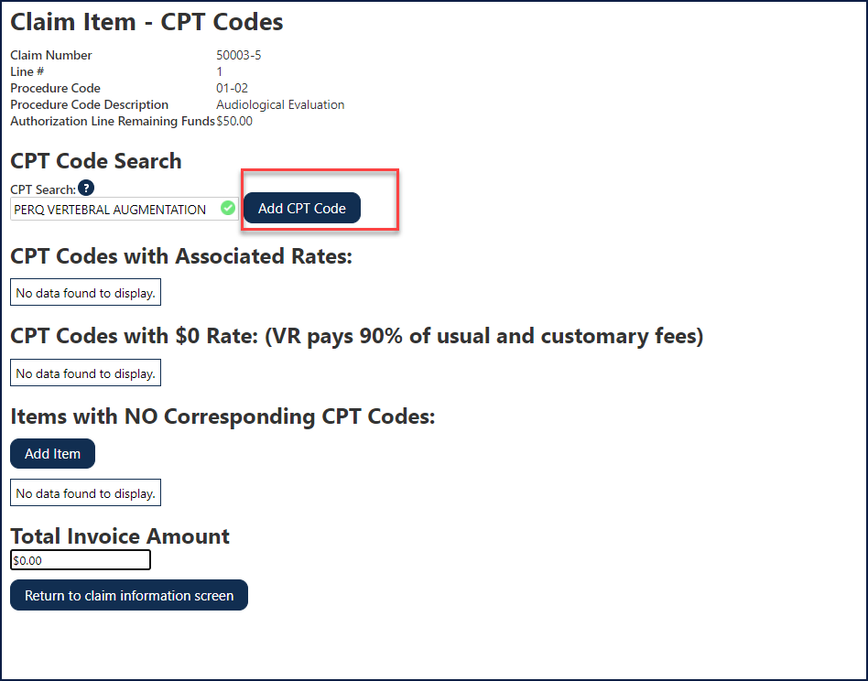
At this point, the CPT code is not added to the Claim Item. Users must click the “Add CPT Code” button (shown below). Once added, the CPT code information displays under the corresponding CPT Codes (CPT Codes with Associated Rates, CPT Codes with $0 Rate, and Items with NO Corresponding CPT Codes) Linked to claim items.

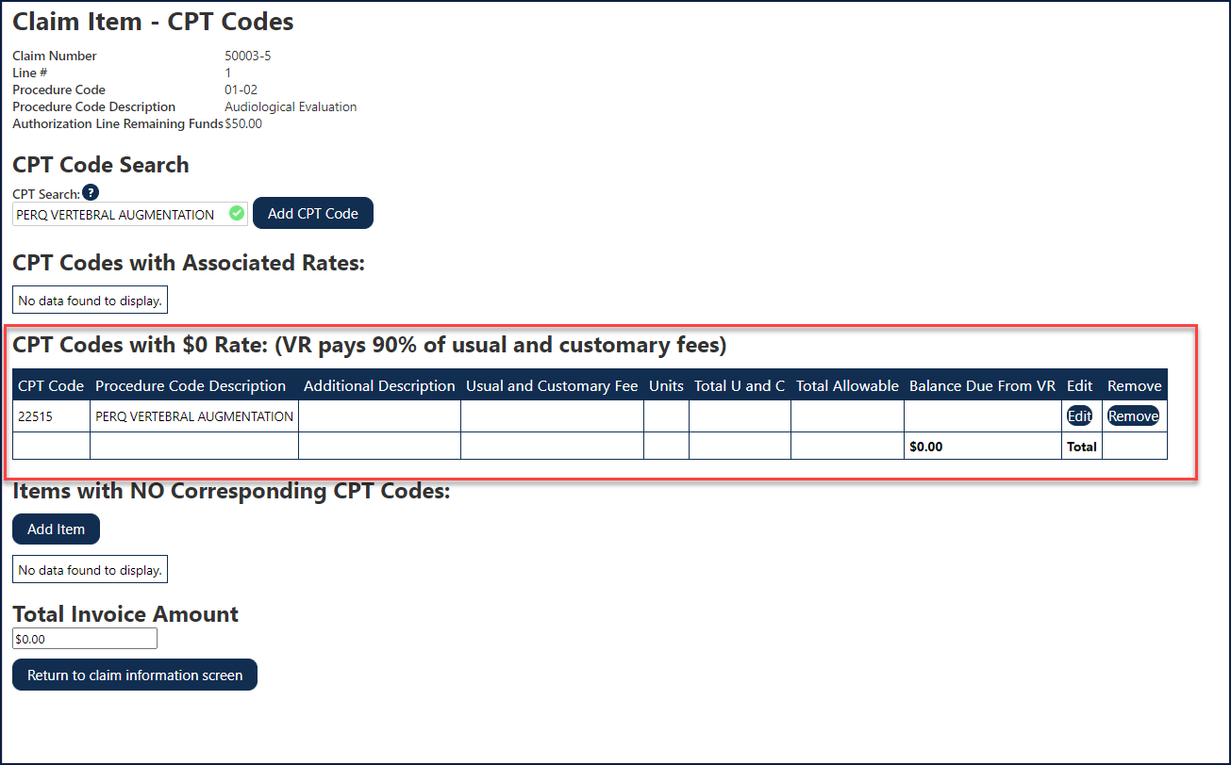

Removing a CPT code

Business Scenario
Users can remove an added CPT code by clicking the Remove hyperlink in the grid on the Claim Item – CPT Codes form (screen).

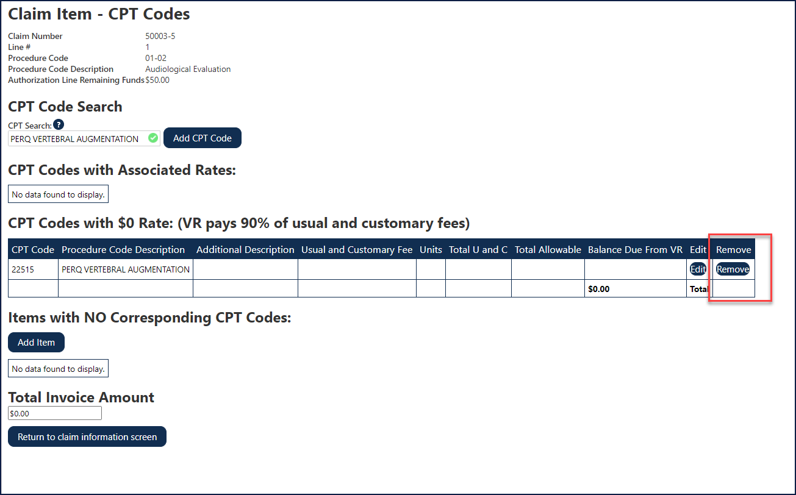

Saving a CPT code
If a User adds a CPT code that has a rate of zero (0), the “Invoice Amount” field is mandatory and will populate after appropriate information is added (additional Description, Usual and Customary Fee and units), then click Save.
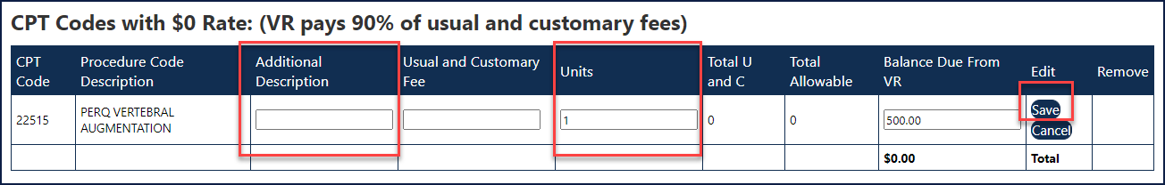

Returning to Claim Information
Step / Action
- Click the Return to claim information screen button, to go back to the Claim Information form/screen (shown below).

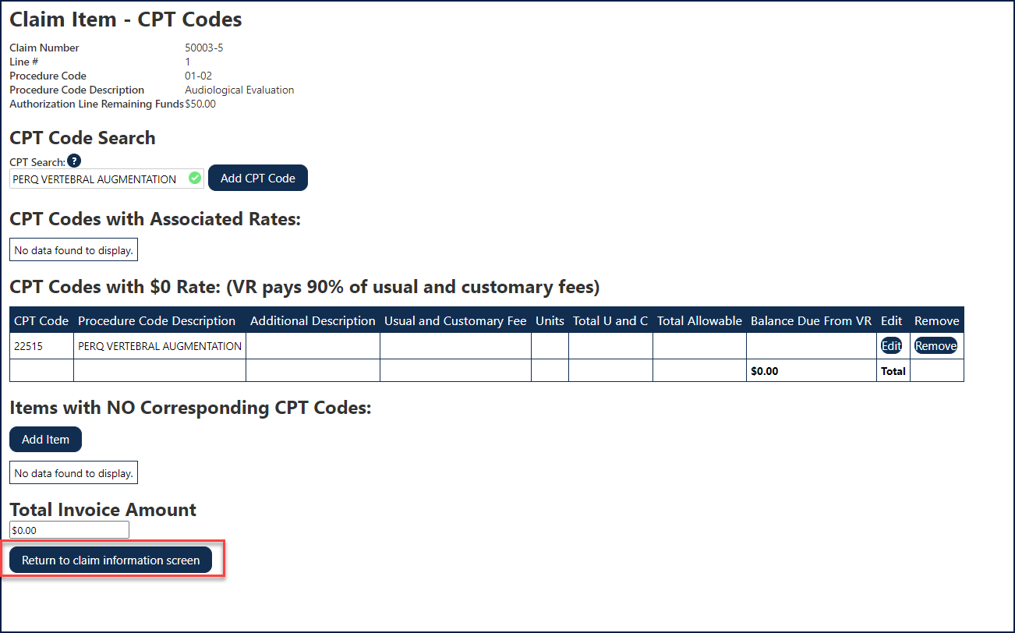

Removing a Claim Item

Business Scenario

Step / Action
- From the Claim Information form (screen), select the appropriate Auth Line number and click the Remove hyperlink.

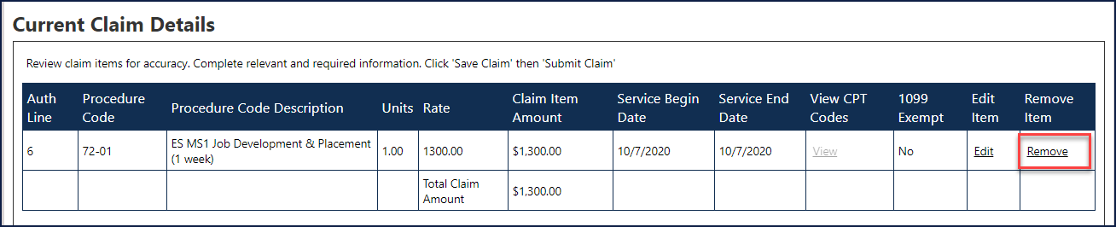

The Claim Items form (screen) displays and the claim is no longer listed (shown below).
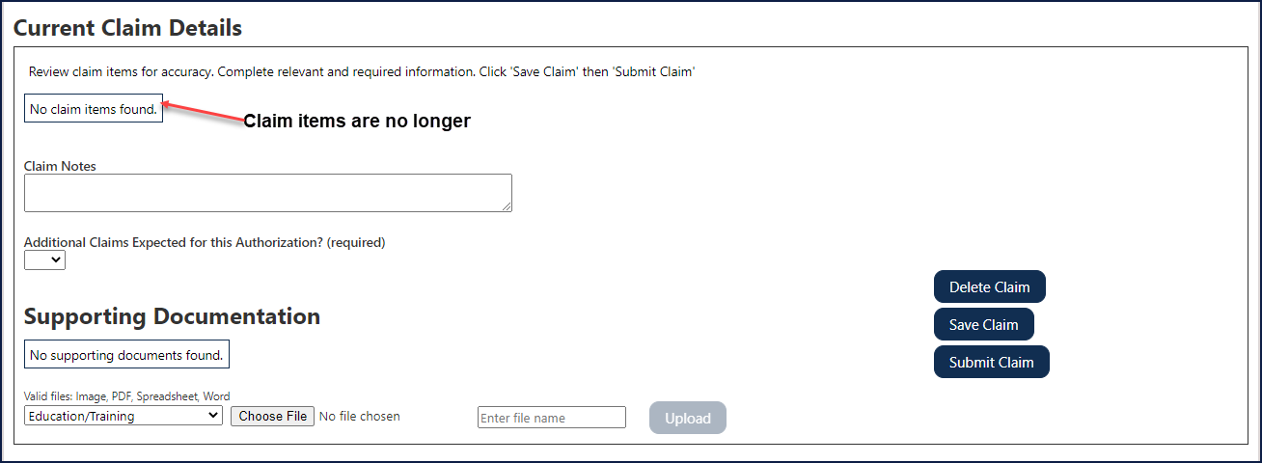

Medicaid Waivers
If there are CPT code(s) for a Service line and there’s a waiver for the authorization, Service/Product Rate can be increased up to amount listed on Authorization for that Service line.
If a Medicaid waiver exists, CPT code requirement is waived. The CPT code function will be disabled.

Adding Additional Information to a Claim
The following section describes fields Users can add to the claim. Keep in mind these fields are added to the claim, not the claim item.

Business Scenario

Step / Action

- Users can add Claim Notes for the entire claim. Claim Notes are for the vendor and are not seen by the VR state staff.

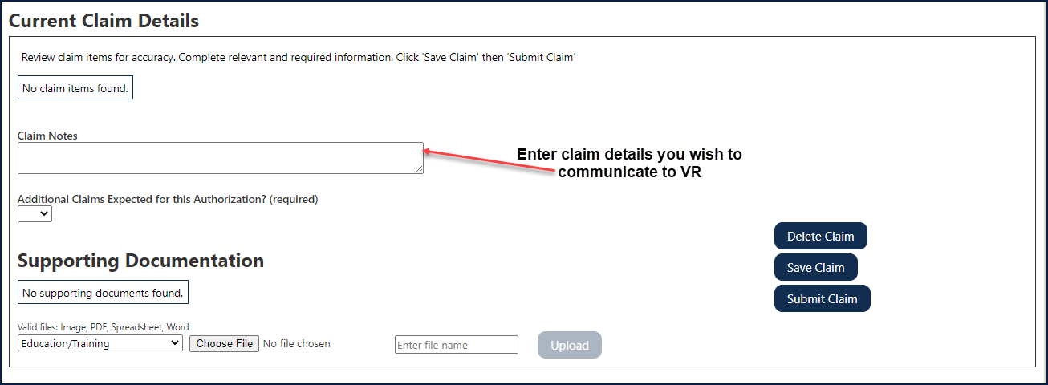

- Users can indicate if there are additional invoices for the authorization. The additional Invoice box is required to be selected. Selecting from the drop-down list are as follows:
- No: Remaining funds of the authorization selected are canceled.
- Yes: Remaining funds are NOT canceled.

If a User indicates “No” for the "Additional invoices" selection, the following message then displays (shown below).

How to Attach a Supporting Document
Step / Action

- Click the drop-down (valid files: image, PDF, Spreadsheet, Word) and select the appropriate document type from the list.

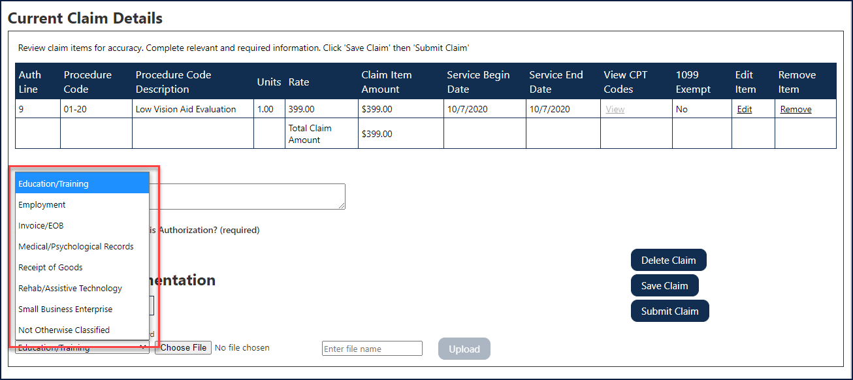

- Next, click the Choose File button (shown below) and using the popup dialog (“Choose file to upload”), select the appropriate document. To confirm file selection, click the Open button on the dialog.

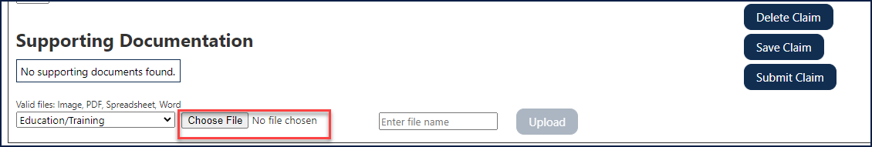
- Enter a file name in the text field and click Upload (shown below).

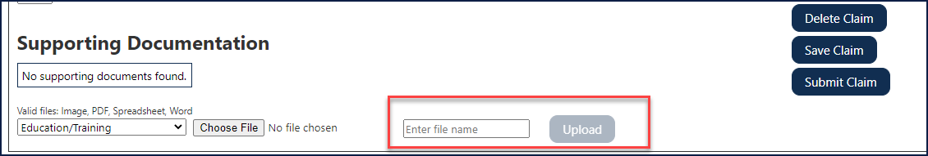

Listed is the Supporting Documentation group, the document is uploaded successfully (shown below).

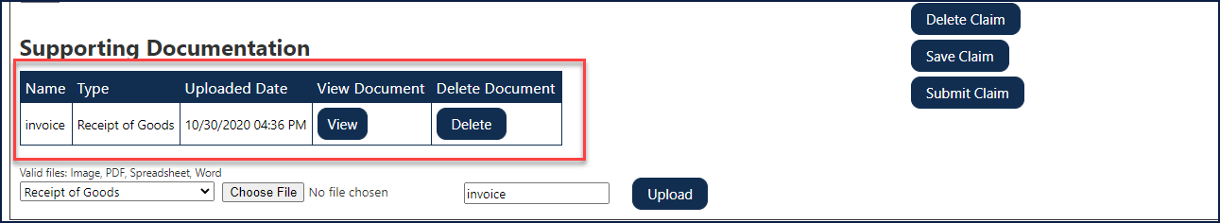

- Once all Additional Information is added to a claim, Users must click the Save Claim button (shown below).

This information (Vendor Invoice Number and Additional Claim expected, will not automatically save when saving a claim item. The Save Claim button must be used.

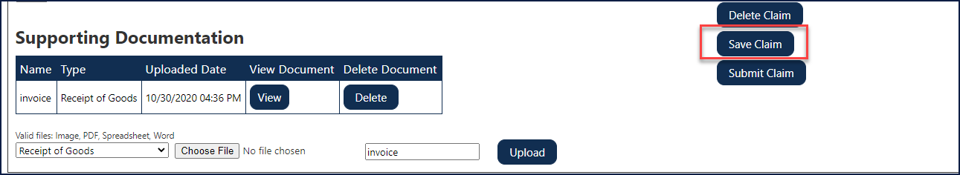

How to Search for a Claim

Business Scenario

Method 1
Step / Action
- From the navigation bar, select/click Participant Lookup (shown below).

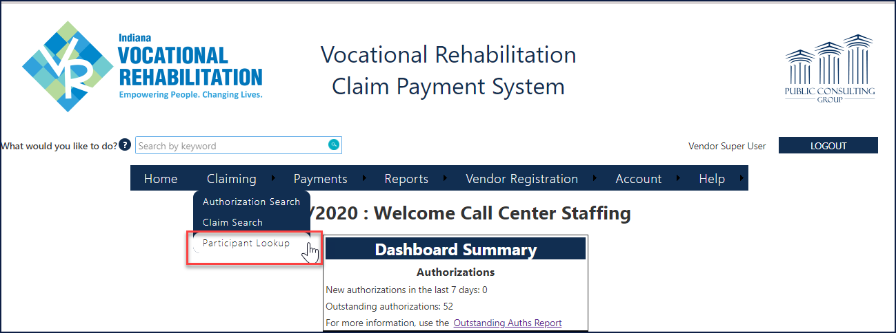

- Enter the Participant’s First and Last name, Client ID or Authorization number and click Search (shown below).

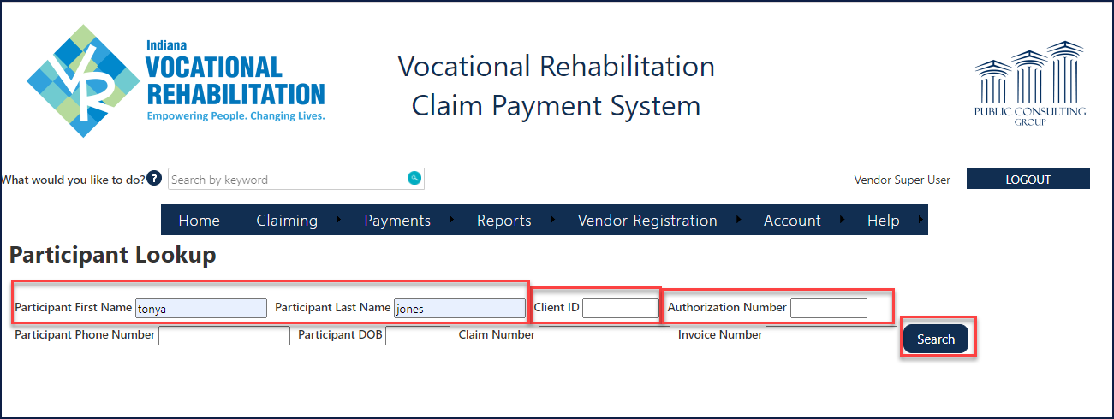

- Click on Details for additional information (shown below).

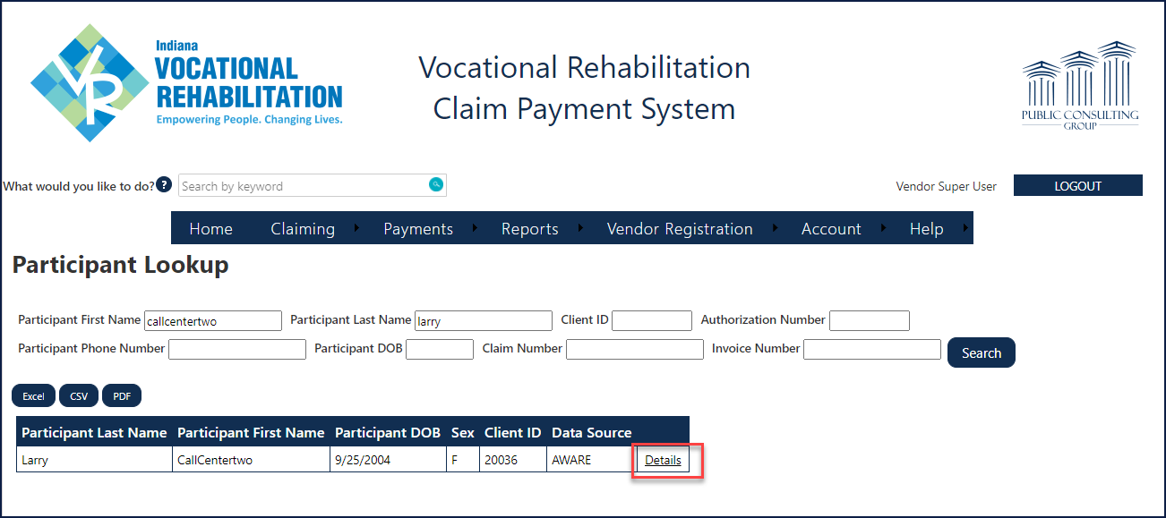

- Under the Claims tab click on the Claim number hyperlink.

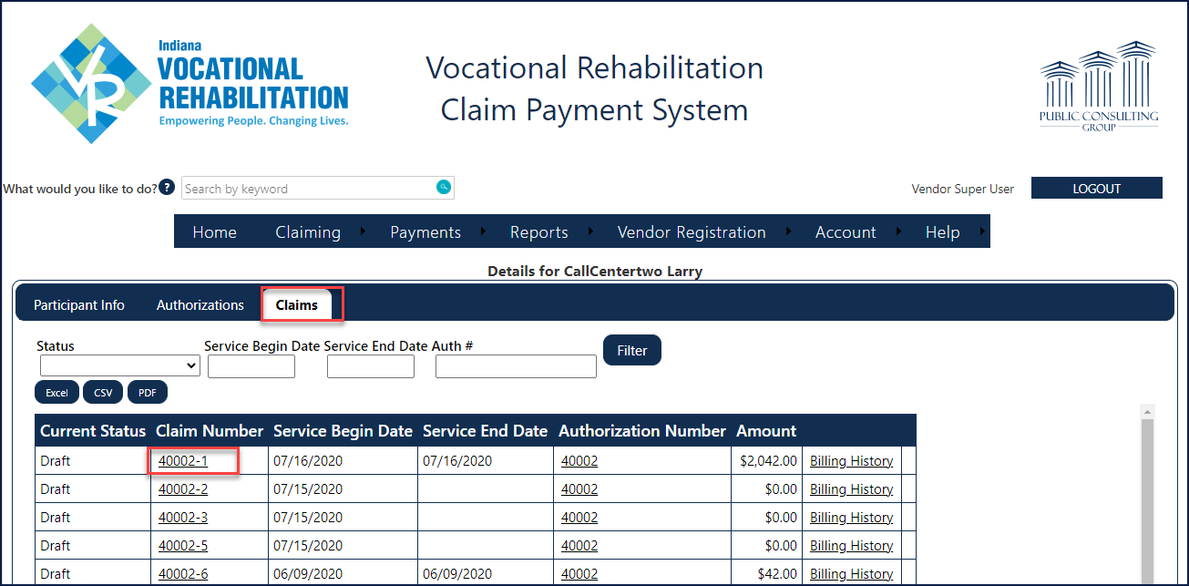

The Claim Information screen displays (shown below).

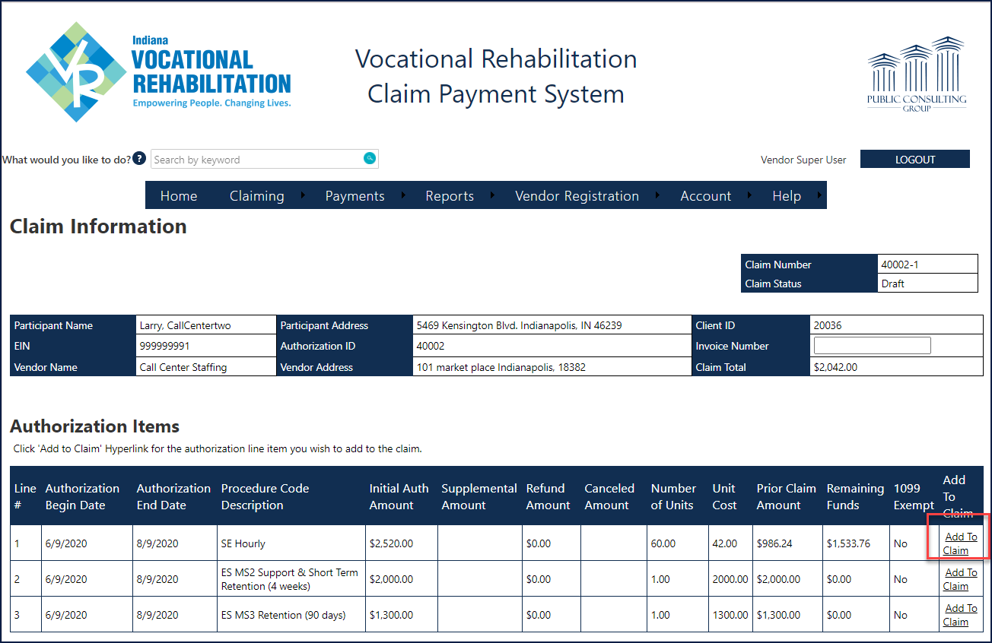

Method 2
Step / Action
- From the navigation bar, select/click Claiming (shown below).

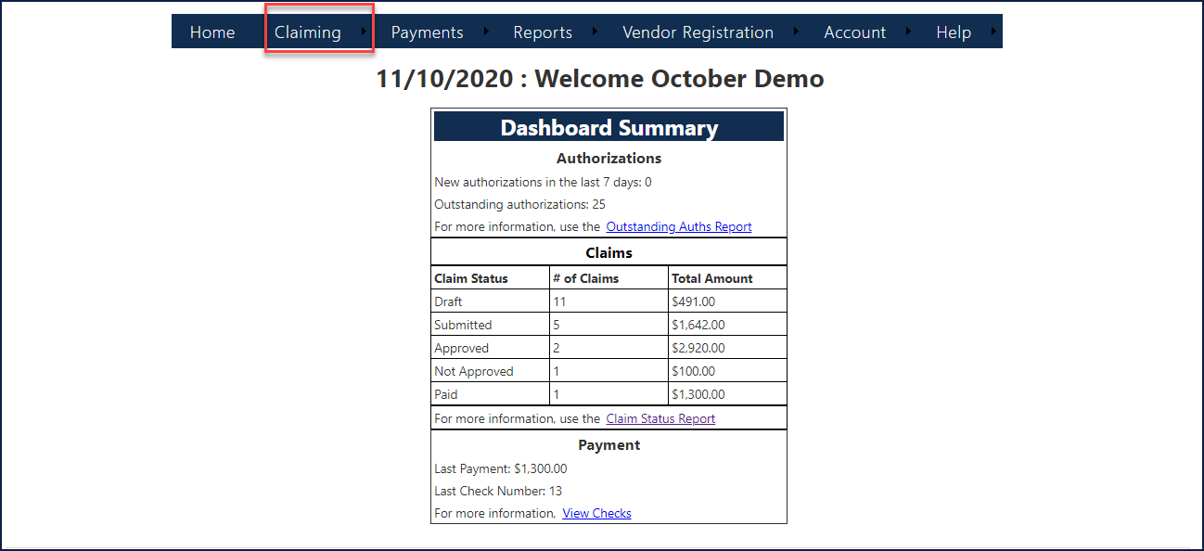
- From the drop-down menu, select/click Claim Search (shown below).

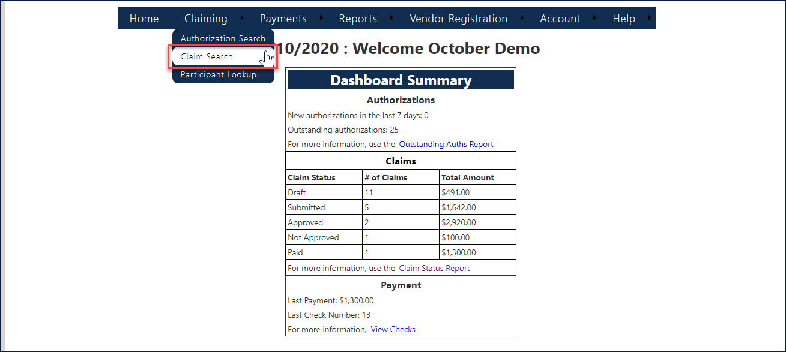

- Select a Participant from the results menu as you type, or, enter multiple search criteria in the text fields.

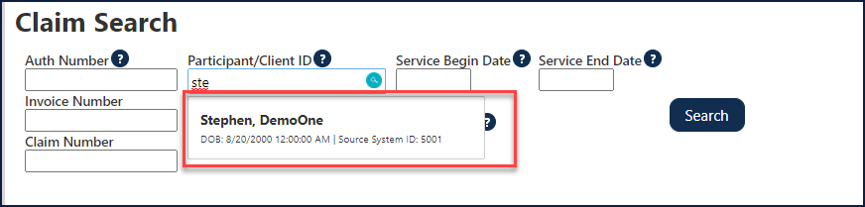

- Enter information in the following fields:
- Auth Number
- Participant/Client ID
- Service Begin Date
- Service End Date
- Invoice Number
- Claim Number
- Claim Created Date

- Click the Search button (shown below).

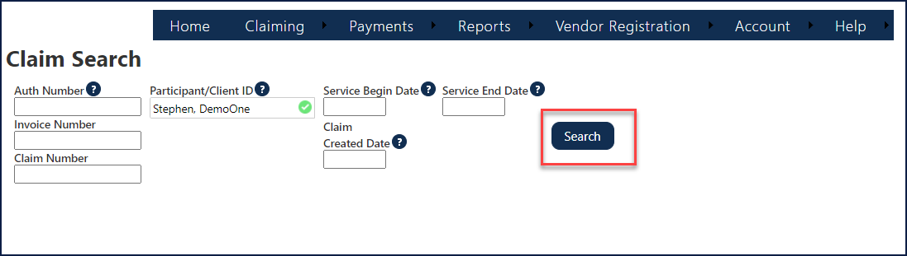

- Click a Claim Number hyperlink to view (shown below).

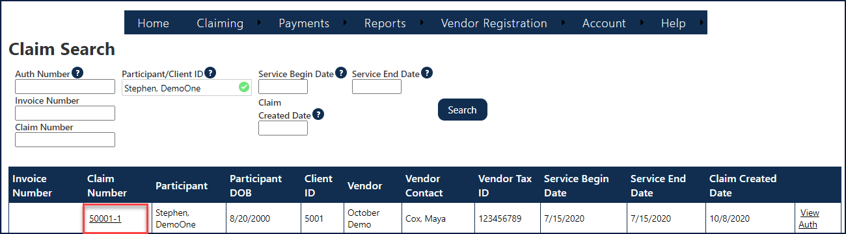

The Claim Information screen displays (shown below).

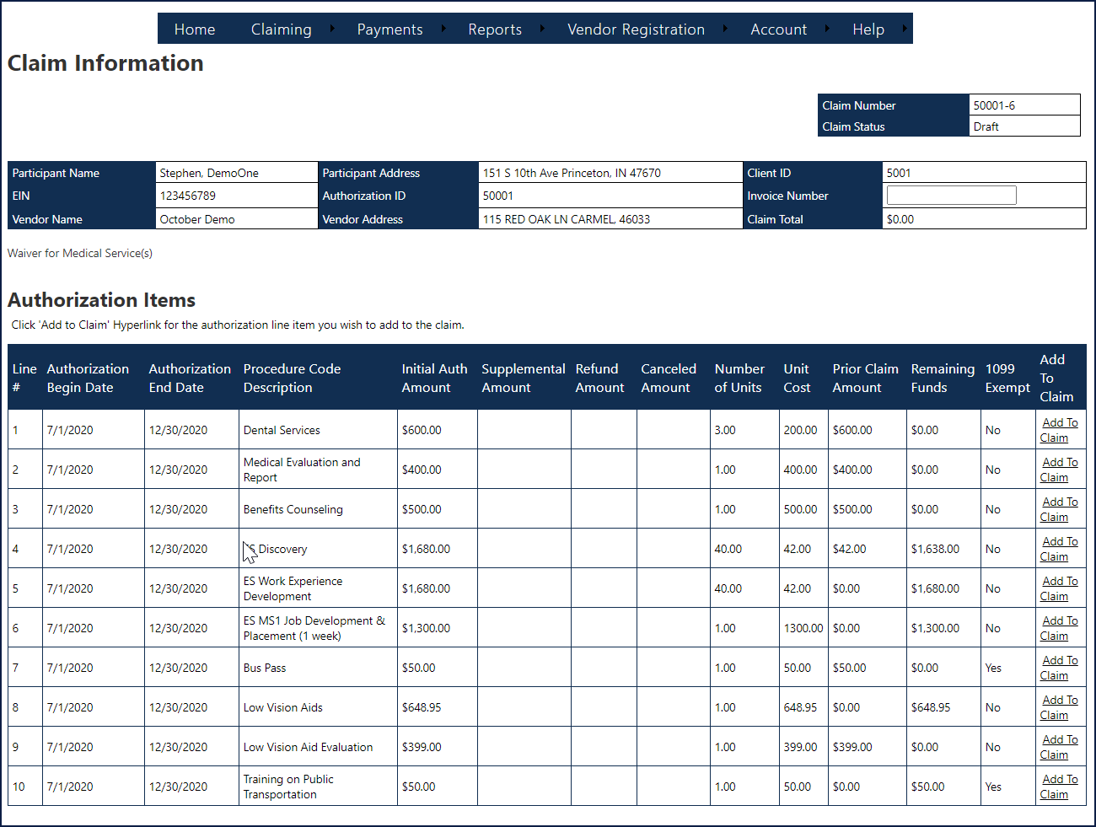
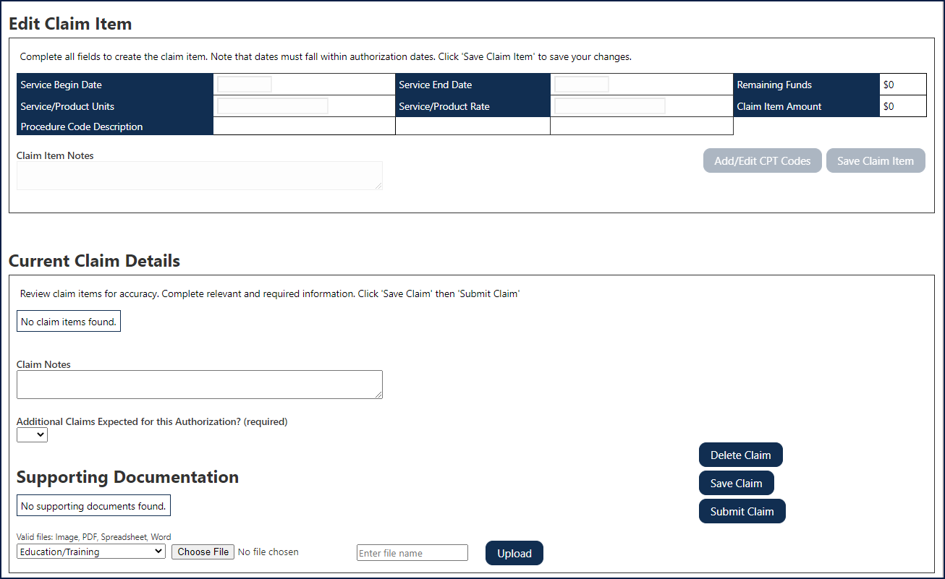

Claim Statuses
Status | Description | User Permissions
Draft | Claim has been started and saved, but not submitted for State review. | The claim can be edited (see roles in Appendix II).
Submitted | Claim has been submitted for State review. | The claim cannot be edited.
Not Approved | The Claim has been reviewed by State staff and the claim needs to be revised and resubmitted for State review. If this occurs, Users will be able to see the Not Approved Reason & Notes to assist in claim modification. | The claim can be edited (see roles in Appendix II).
Not Approved – Removed | The Claim has been reviewed by State staff and the claim needed to be revised. The claim has subsequently been removed. | The claim cannot be edited.
Approved | The Claim has been reviewed by State staff and the claim is approved for payment. | The claim cannot be edited.
Paid | The Claim has been paid. | The claim cannot be edited.

Finding Information and Reporting

Participant Lookup- Preferred method to view all authorizations and claims for a participant.

Business Scenario

Step / Action

- From the navigation bar, select/click Claiming (shown below).

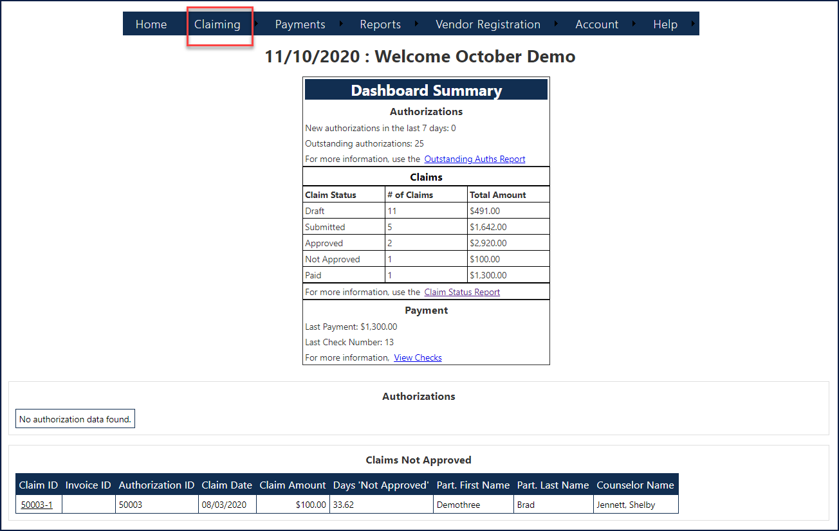

- Select/click Participant Lookup from the drop-down menu (shown below).

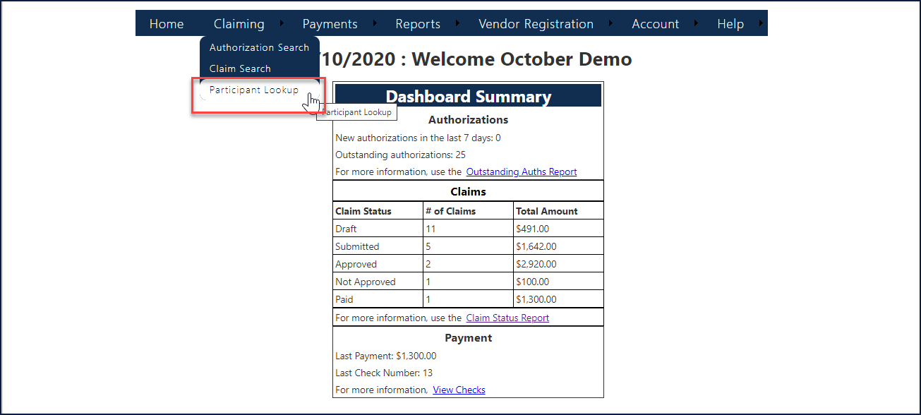

- Enter the information in the following fields- NOT all items are needed to search:
- Participant First Name
- Participant Last Name
- Client ID
- Authorization Number
- Participant Phone Number
- Participant DOB
- Claim Number
- Invoice Number

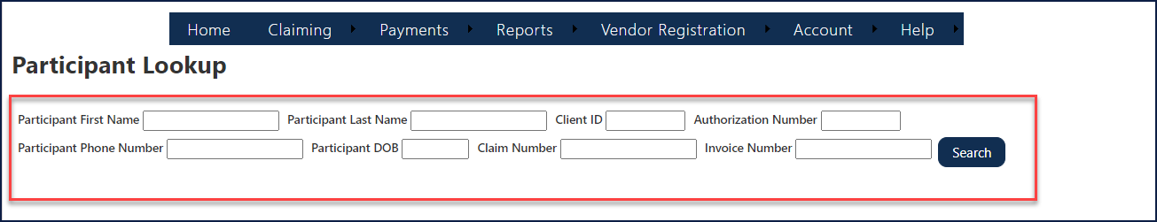

- Next, click the Search button (shown below).

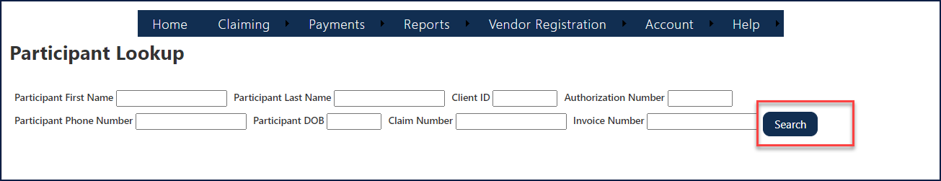

The Participant data displays (show below).

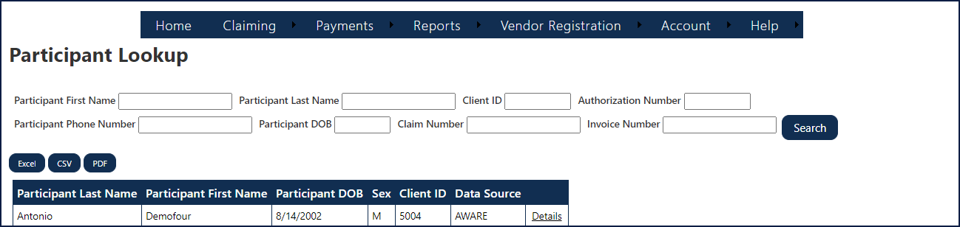

Accessing Participant Details (Multi-tabbed)
Step / Action

- Click the Details hyperlink of a participant (shown below).

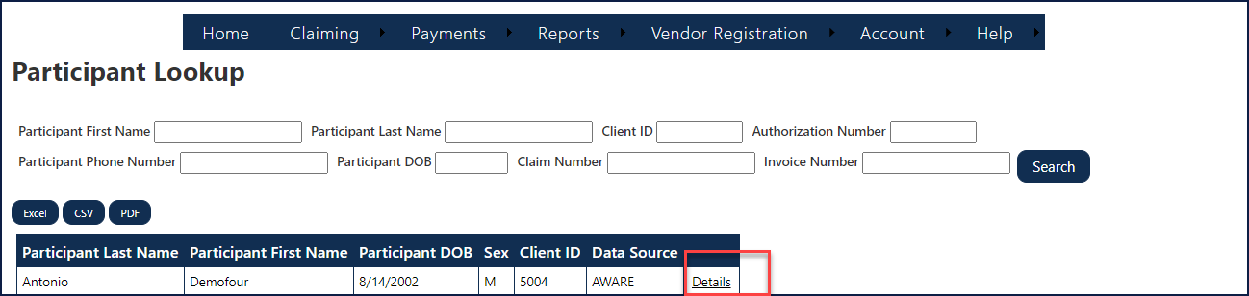

Participant Info Tab
The complete data for the selected participant displays (shown below). Use the tabs to view particular details for the participant, including Participant Info, Authorizations, and Claims.

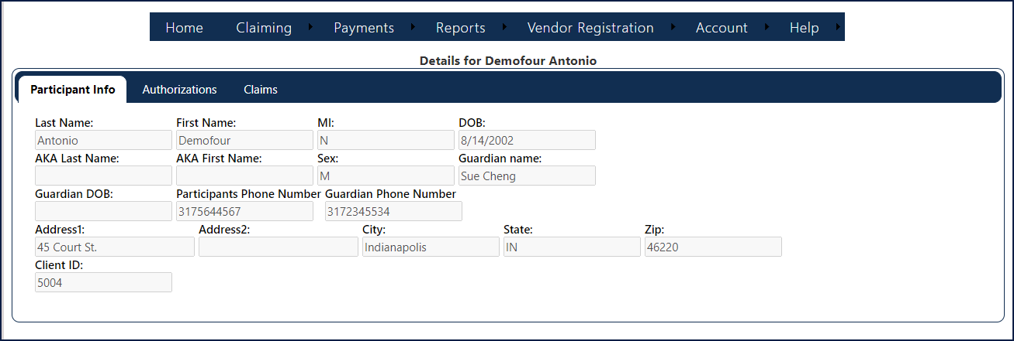

Authorizations Tab-Best view of all the authorizations for this participant.
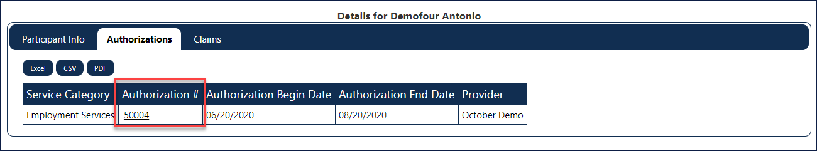
The “Authorization #” is a hyperlink to the Authorization Information form (screen).

Claims Tab-Best view of all claims for this participant and the status of each claim. Vendor can navigate to draft or not approved claims to modify and re-submit by clicking the claim #.
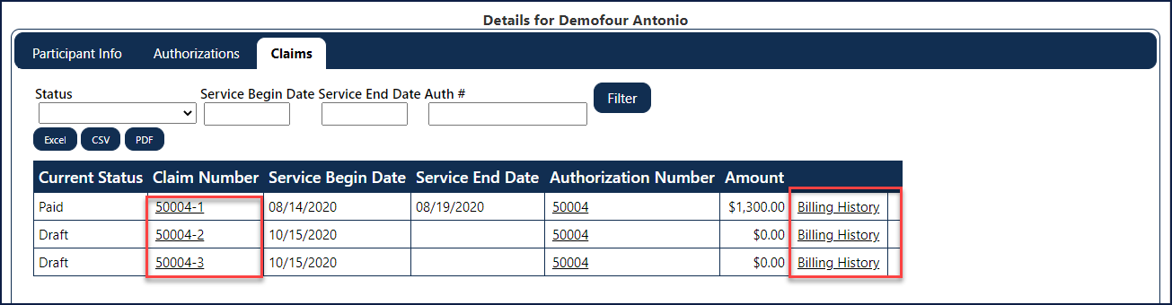
The “Claim Number” is a hyperlink to the Claim Information form (screen) and the “Billing History” hyperlink will navigate Users to the Billing History form (screen).

Payments

View Checks

Business Scenario

Step / Action

- From the navigation bar, select/click Payments, and select/click View Checks from the drop-down menu (shown below).
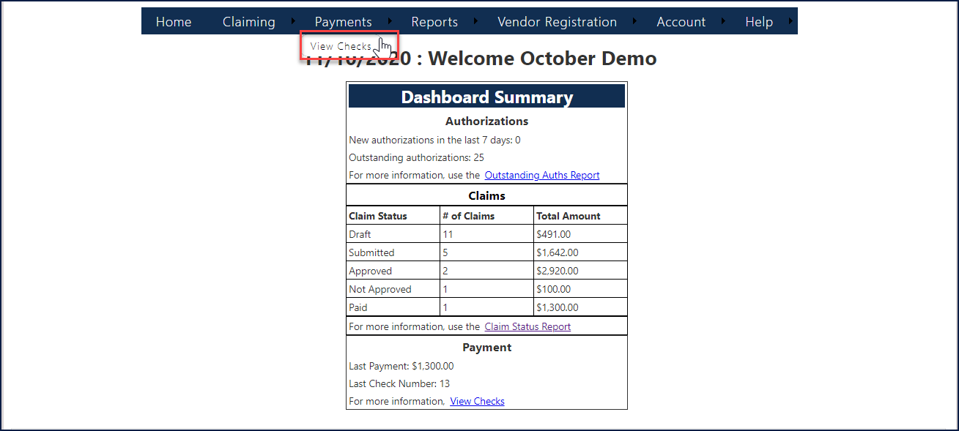

- Next, enter a date range (example shown below) and click the Filter button.
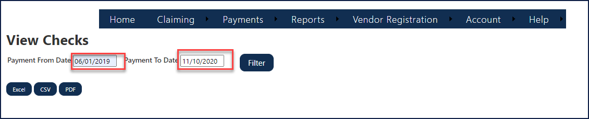

- The data results display in a spreadsheet/grid (shown below).
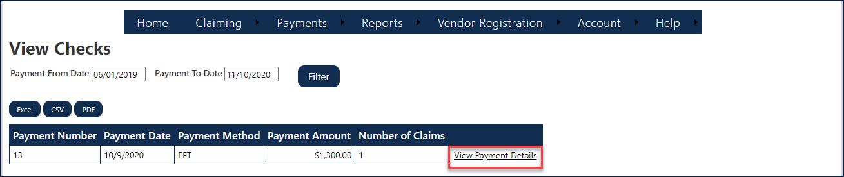

Viewing Payment Details
Step / Action

- Click the View Payment Details hyperlink on the row to see more information on a payment.

The data for the selected check displays a spreadsheet/grid (shown below).

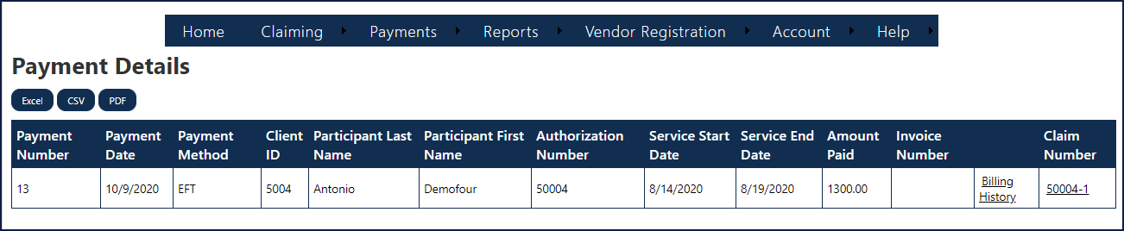

State Users Only: Finding Information and Reporting

Invoicing Details

Business Scenario

Step / Action

- From the navigation bar, select/click Payments, and select/click Invoicing Details from the drop-down menu (shown below).
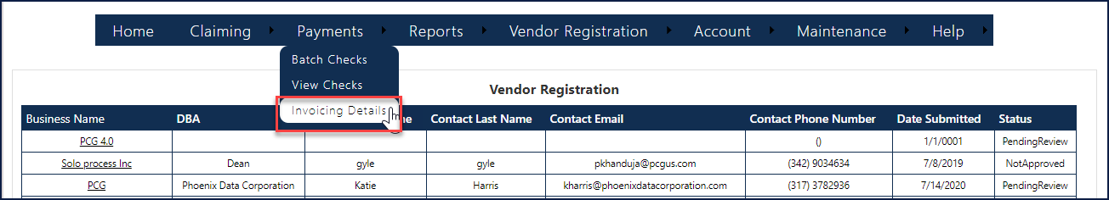

- Enter a date range (example shown below).
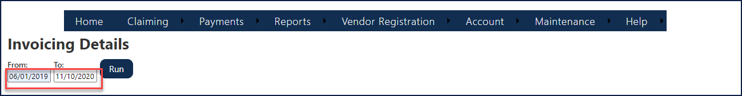

- Click the Run button. The Invoicing Details data results in displays in a spreadsheet/grid (shown below).
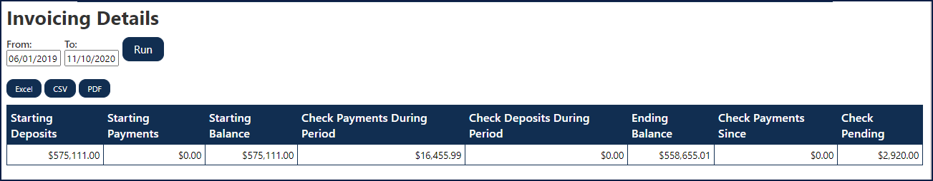

Batch Checks

Business Scenario

Step / Action

- From the navigation bar, select/click Payments, and select/click Batch Checks from the drop-down menu (shown below).

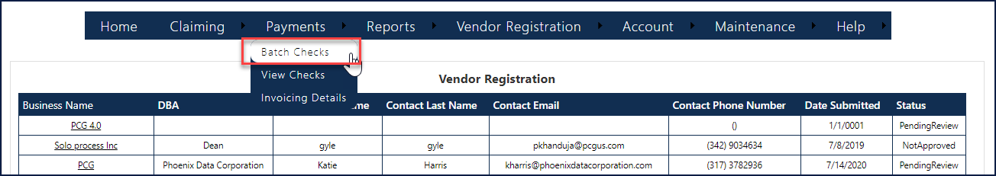
- Select a Batch from the drop-down menu (shown below).

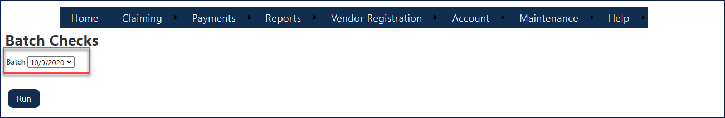
- Click the Run button (shown below).

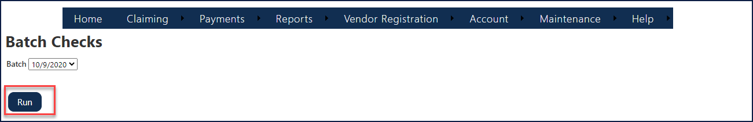

The Batch Checks data displays in a grid (shown below).

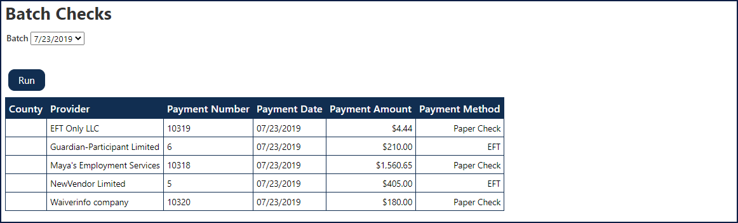

Refunds
FSSA currently receives refund payments from vendors. To accurately reflect refund amounts within CPS and on 1099’s issued by PCG, refund information will be available to users in several different places.
On the Claim Information Screen, in the ‘Authorization Items’ table, refund information will be populated in the column ‘Refund Amount’. This information will be related to the authorization line item (shown below).
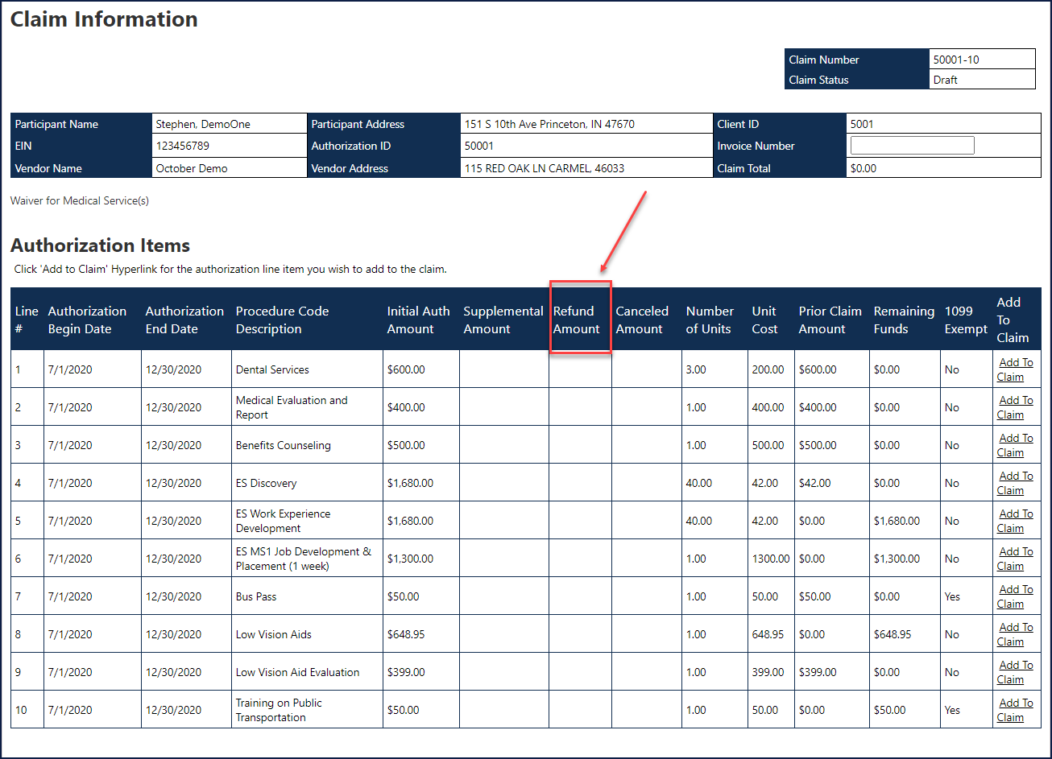

On the Authorization Research Report, refund amounts by authorization will be populated in the existing column ‘Total Fund Recovery’ (shown below).
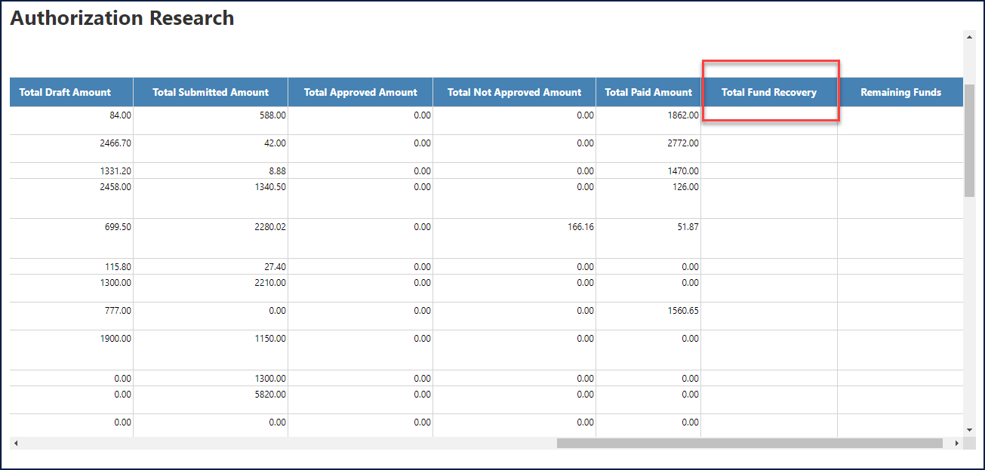

On the Outstanding Authorizations Report Refund amounts by authorization line item will be populated in the existing column, ‘Fund Recovery Amount’ (shown below).
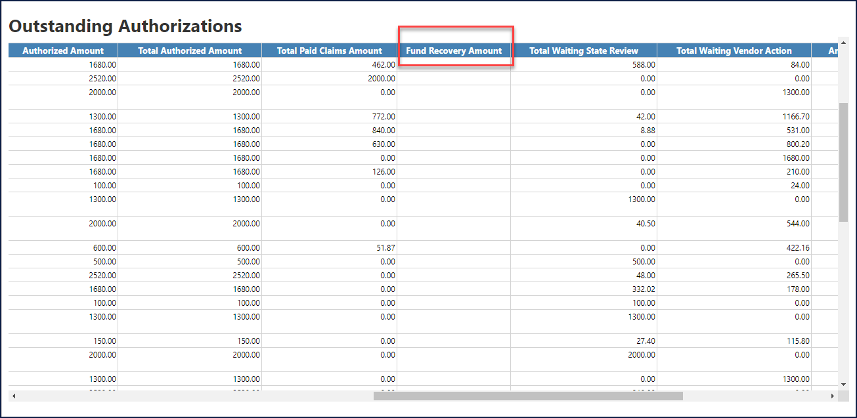

User Statistics

Business Scenario

Step / Action
- From the navigation bar, select/click Reports, and select/click User Statistics from the drop-down menu (shown below).

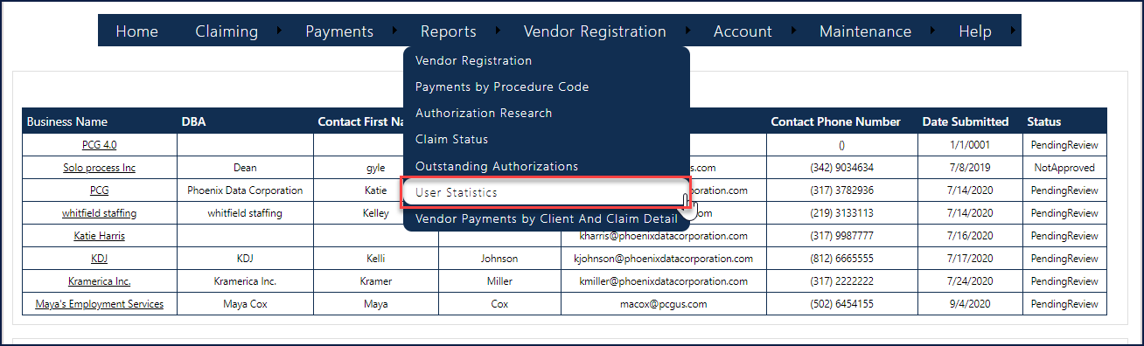

The User statistic data displays (shown below).

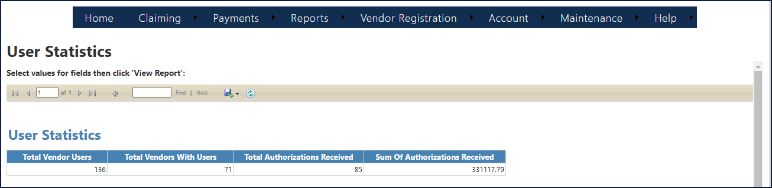

Reports

Business Scenario

Payments by Procedure Code
The Payments by Procedure Code report displays all payments made based on the search criteria. This report displays a single line per service code.

Business Scenario

Step / Action
- From the navigation bar, select/click Reports, and select/click Payments by Procedure Code from the drop-down menu (shown below).

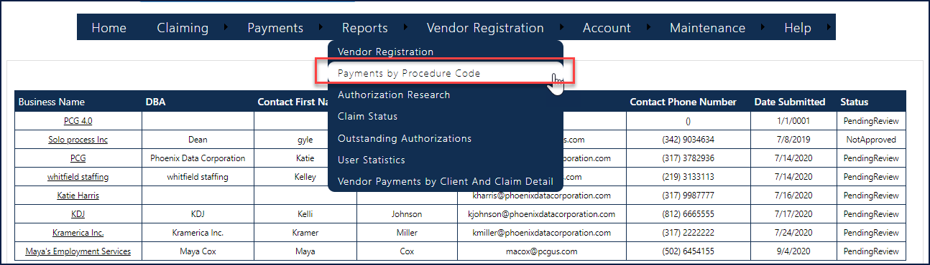

- Enter the information in the following fields (shown below):
- Select Region
- Select Area
- Select Caseload
- Select Payment Start Date (00/00/0000)
- Select Payment End Date (00/00/0000)

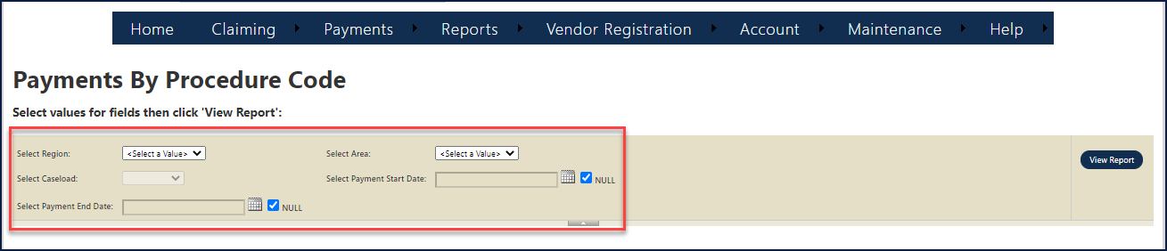

- Click the View Report button.

The Payments by Procedure Code data displays (shown below).

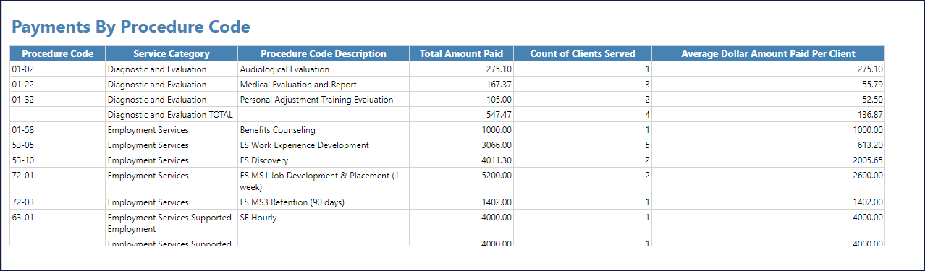

Authorization Research
The Authorization Research report displays all authorizations based on the search criteria.

Business Scenario

Step / Action

- From the navigation bar, select/click Reports, and select/click Authorization Research from the drop-down menu (shown below).

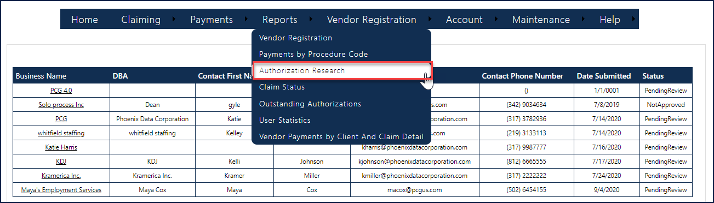

- Click/Select the appropriate Select Service Type from the drop-down list (shown below).

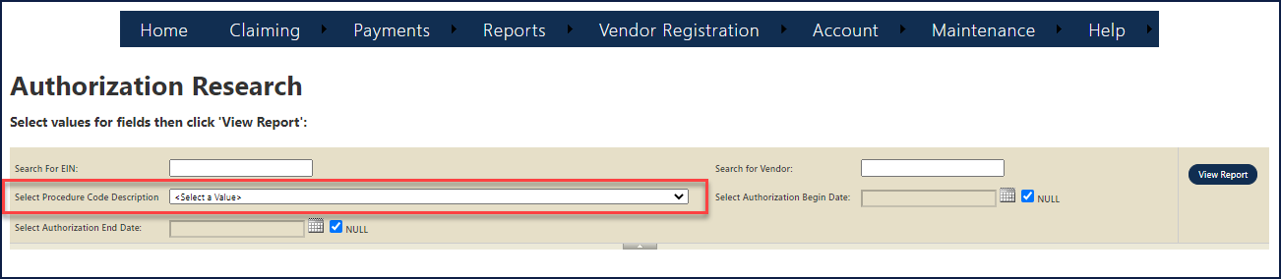

- Click the View Report button.

The Authorization Research data displays (shown below).

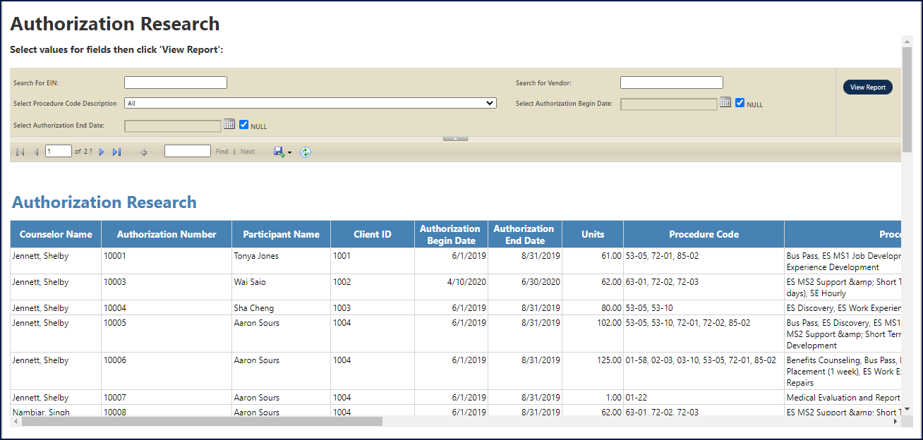

For Vendor Users, the “Search for FEIN” and “Search for Vendors” are prepopulated with the Vendor/EIN (Vendors cannot see anyone but themselves).

Claim Status
The Claim Status report displays claims that are in draft, not approved, not approved removed, submitted, approved and paid status. This report will display a single line per claim number.

Business Scenario

Step / Action

- From the navigation bar, select/click Reports, and select/click Claim Status from the drop-down menu (shown below).

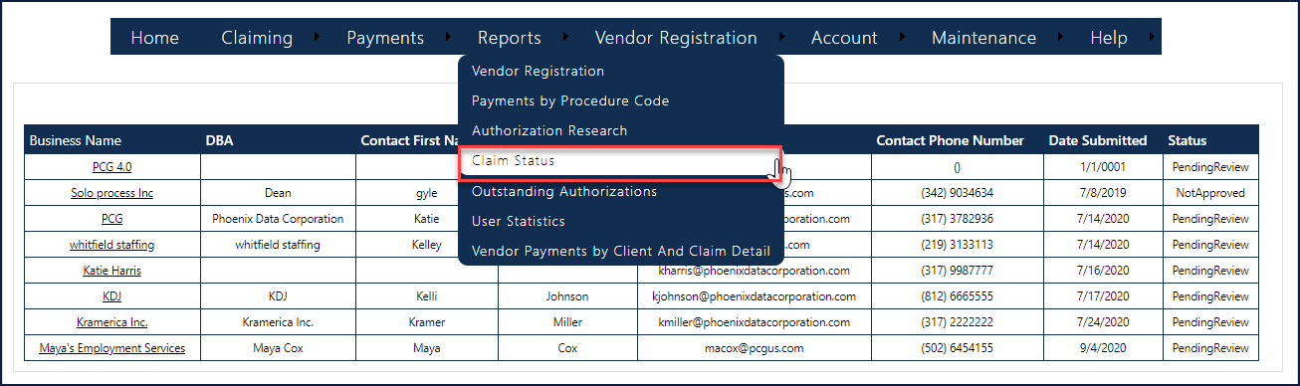

- Enter the information in the following fields (shown below):
- Select Region
- Select Area
- Select Caseload
- Service Claim Status
- Select Service Begin Date (00/00/0000)
- Select Service End Date (00/00/0000)

- Click the View Report button.

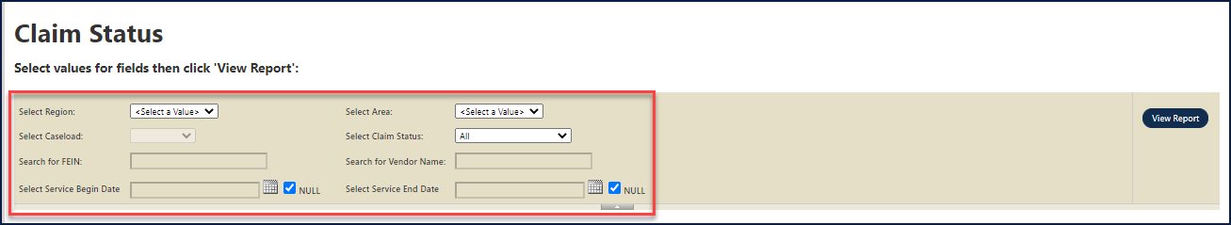

The Claim Status data displays in a grid (shown below).
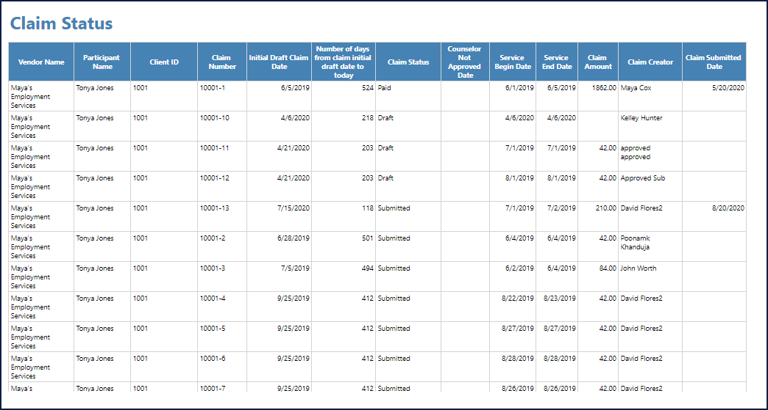

Outstanding Authorizations
The Outstanding Authorizations report displays all authorizations that have remaining funds available (the remaining fund's field does not equal zero (0)). This report will generate a single line per authorization line; for example, an authorization can display multiple times if the authorization has multiple authorization lines with remaining funds.

Business Scenario

Step / Action

- From the navigation bar, select/click Reports, and select/click Outstanding Authorizations from the drop-down menu (shown below).

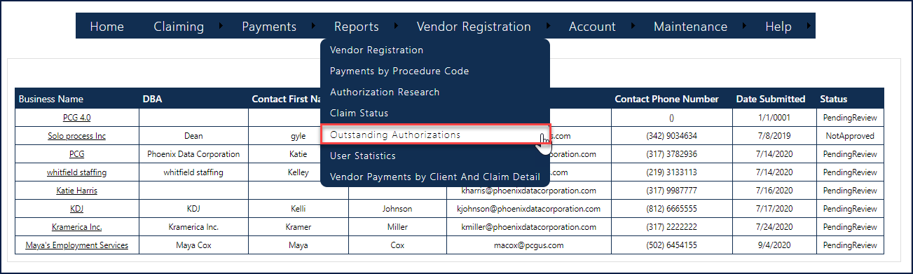

- Select/Click the appropriate Select Region and area Type from the drop-down list (shown below).

- Click the View Report button.

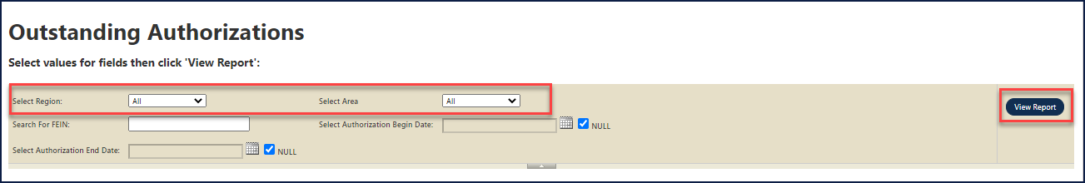

The Outstanding Authorizations data displays in a grid (shown below).

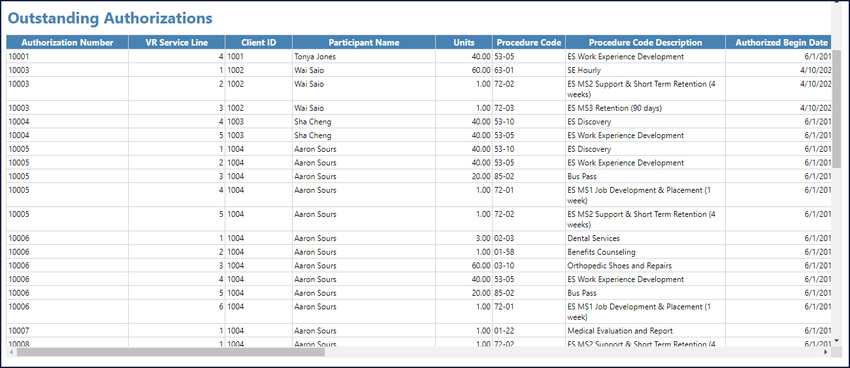

Vendor Payments by Client and Claim Detail
The Vendor Payments by Client and Claim Details report displays all claims in a paid status. This report will display a single line per claim.

Business Scenario

Step / Action

- From the navigation bar, select/click Reports, and select/click Vendor Payments by Client And Claim Detail from the drop-down menu (shown below).

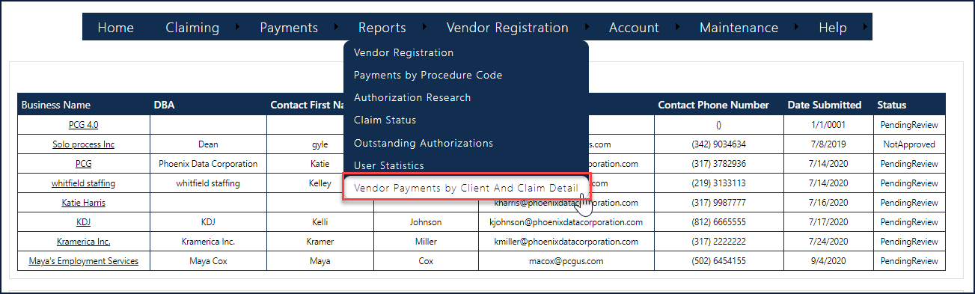

2. Enter the information in the following fields (shown below):
- Search for FEIN
- Search for Vendor Name
- Select Service Begin Date
- Select Service End Date
- Select Fiscal Year
- Select Payment Number
- Select Payment From Date
- Select Payment To Date

3. Click the View Report button.

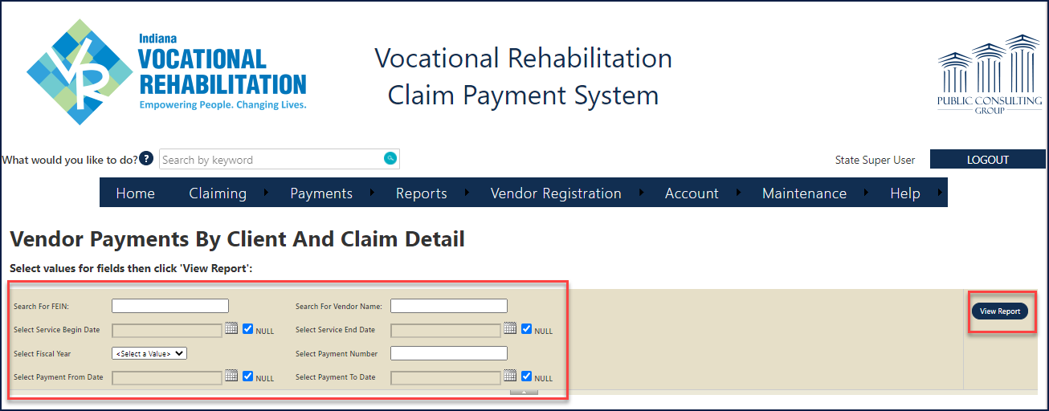

The Vendor Payments by Client and Claim Detail displays in a grid (shown below).

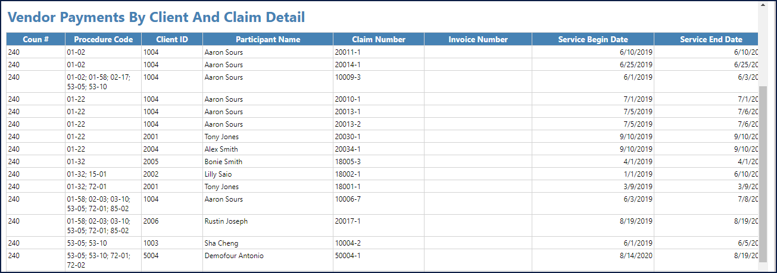

For Vendor Users, the “Search for FEIN” and “Search for Vendors” are prepopulated with the Vendor/EIN (Vendors cannot see anyone but themselves).

Appendix A

  - Report Navigation Bar
All controls are visible in Microsoft Internet Explorer (IE), but not in Microsoft Edge, Chrome, or Firefox. Recommend Microsoft IE for full functionality.
The operational icon buttons numerically reference above are referenced in the table below.

REF # | ACTION ICON BUTTON | DESCRIPTION
1 | First Page | When clicked, jumps to the first page (Beginning). You must be viewing pages 2 for this function to be operative.
2 | Previous Page | When clicked, goes back a page (must be viewing pages 2 and on).
3 | Current Page and Page Total | Displays the current page. To manually choose a specific page, type in a number (e.g., viewing pages 1-10).  If the page is not available for the given page number, the viewer retains the existing page in view.
4 | Next Page | When clicked, advances to the next page (must be viewing pages 2 and on).
5 | Last Page | When clicked, jumps to the last page (End).
6 | Zoom Value | To enter the page viewing, enter a percentage value or select the appropriate percentage from the popup menu.  Actual Size displays the page at 100% magnification.
7 | Report Search Textbox | To find a specific name or value (alphanumeric), enter it into this textbox.
8 | Export (drop-down menu) | Click on the drop-down arrow and select the appropriate export file format from the menu shown below:  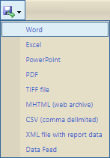
9 | Refresh | When clicked, the data results in the spreadsheet/grid are refreshed based on values changed in any search fields/textboxes (e.g., Using the Authorization Research form and altering the values listed in the "Search For EIN" field).
19 | Print | When clicked, data shown in the spreadsheet/grid is printed using the browser’s default printer settings.

Appendix B

  - Roles Matrix

Permissions Key:
- R = Read Only Access
- U = Update Access
- N = No Access

Role | Claiming Screens
 | Authorization Search | Claim Search | Authorization Information | Draft Claim Information | Not Approved Claim Information | Sub. In Proc or Paid Claim Info | File Upload-Claim Information | Billing History
State
StateReader | R | R | R | R | R | R | R | R
StateStandard | R | R | R | U | U | R | R | R
StateSuperUser | R | R | R | U | R | R | U | R
Vendors
SuperVendor | R | R | R | U | U | R | U | R
SubVendor | R | R | R | U | U | R | U | R

Role | Claiming Functionality
 | Submit Claim more than 90 days | Submit Claim Created by another user
State
StateReader | N | N
StateStandard | N | N
StateSuperUser | U | U
Vendors
SuperVendor | N | U
SubVendor | N | N

Role | Payment-All |  |  |  | Payment-State |  | Other
 | View Checks | Check Summary | Payment Details |  | Batch Check | Invoicing Details | Participant Lookup
State
StateReader | R | R |  | R | R | R | R
StateStandard | R | R |  | R | R | R | R
StateSuperUser | R | R |  | R | R | R
Vendors
SuperVendor | R | R |  | R | N | N | R
SubVendor | R | R |  | R | N | N | R

Role | Reports
 | Vendor Payments by Client and Claim Detail | Outstanding Authorizations | Claim Status | Authorization research | User Statistics | Payments by CC Code | Vendor Registration
State
StateReader | R | R | R | R | R | R | R
StateStandard | R | R | R | R | R | R | R
StateSuperUser | R | R | R | R | R | R | R
Vendors
SuperVendor | R | R | R | R | N | R | N
SubVendor | R | R | R | R | N | R | N

- State Super Users can Edit, Delete or submit any Claim.
  - Vendor Super Users can edit or submit any claim within a 90 day timeframe.
- Other Users can only Edit, Delete, or Remove claims entered by them only. Even the User with the same role cannot perform the above actions.
- State Read Only User can only view all the Claims in read-only mode.
- Vendors of other organization cannot view information not related to their organization.

Appendix C

  - Acronym List
Term | Description of Term
BR | Business Requirement
BRD | Business Requirement Document
CMS | Case Management System
CPS | Claim Payment System
CRP | Community Rehabilitation Provider
EFT | Electronic Fund Transfer
FEIN | Federal Employer Identification Number
FSSA | Family and Social Services Administration
ID | Identification
IOT | Indiana Office of Technology
IRIS | Indiana Information Rehab System
PCG | Public Consulting Group
PDF | Portable Document Format
RTM | Requirements Traceability Matrix
SSN | Social Security Number
TFS | Team Foundation Server
VR | Vocational Rehabilitation

Appendix D

D.1 Service Types Matrix
Service Categories in CPS | Service Type | Service Sub Type
Assessment | - Licensed physicians  - Registered occupational therapists  - Licensed psychologists  - Licensed optometrists  - Licensed podiatrists  - Licensed speech-language pathologists  - Licensed audiologists  - Licensed speech and hearing therapists  - Licensed nurses  - Licensed alcohol and drug addiction counselors  - Licensed clinical social workers  - Licensed physician assistants  13) Other Assessment Services (specify)
Diagnosis and Treatment | - Corrective surgery or therapeutic treatment  - Mental health services  - Dentistry  - Nursing services  - Medications and supplies  - Prosthetic, orthotic or other assistive devices  - Hearing Aids and Dispensers  - Eyeglasses and visual services  - Podiatry  - Physical therapy  - Occupational therapy  - Speech or hearing therapy  - Special services (i.e. transplantation, dialysis, etc.)  - Other Diagnostic and Treatment Services (specify)
Training | - Post-Secondary Training/Education  - Technical Training  - Disability-Related Skills Training  - Other Training (see sub-type) | 2 a) Occupational Training  2b) Vocational Training  2c) Other Technical Training (specify)  3a) Orientation and Mobility Training  3b) Rehabilitation training  3c) Low vision aid training  3d) Braille training  3e) Speech reading training  3f) Sign language training  3g) Cognitive training/retraining  3h) Other Disability Skills Training (specify)  4a) On-the-Job Training  4b) Apprenticeship Training  4c) Remedial or Literacy Training  4d) Other Training Not Covered (specify)
Rehabilitation Technology | - Rehabilitation Engineering Service  - Assistive Technology Devices  - Assistive Technology Services  - Home Modification Services  - Vehicle Modification Services  - Other Rehabilitation Technology (specify) | 1a) Mobility  1b) Communications  1c) Hearing  1d) Low Vision/Blind  1e) Cognition  1f) Other Rehab Engineering Services (specify)  2a) Off-the-Shelf Devices  2b) Customized or Modified Devices  3a) AT Evaluation Services  3b) AT Purchasing/Leasing Services  3c) Repair/Customize/Fit/Design AT Devices  3d) Coordinating/Therapy/Interventions with AT  3e) AT Training or Technical Assistance  3f) Other AT Services (specify)  4a) Home Modification Evaluation  4b) Home Modification Contractor  4c) Other Home Modification Services (specify)  5a) Vehicle Modification Provider  5b) Vehicle Modification Evaluation  5c) Driver Training  5d) Driver Evaluation  5e) Other Vehicle Modification Services (specify)
Transportation Services | - Transportation Training  - Other Transportation Services (specify)
Personal Assistance Services | - Reader Services  - Personal Attendant Service  - 3) Other Personal Assistance Services (specify)
Technical Assistance Services | - Small Business Consultation  - Other Technical Assistance Services (specify) | 1a) Business plan development  1b) Conduct market research  1c) Other Small Business Services (specify)
Communication Access Services | - ASL Interpreter  - Certified Deaf Interpreter  - Tactile Interpreter  - Oral Interpreter  - Signing Exact English  - Video Remote Interpreting (VRI)  - C-PRINT  - Remote CART  - Live CART  - 10) Other Communication Access Services (specify) | 1a) Nationally Certified  1b) IIC  1c) National Certified and IIC  1d) Non-IIC  2a) Nationally Certified  2b) IIC  2c) National Certified and IIC  2d) Non-IIC  3a) Nationally Certified  3b) IIC  3c) National Certified and IIC  3d) Non-IIC  4a) Nationally Certified  4b) IIC  4c) National Certified and IIC  4d) Non-IIC  5a) Nationally Certified  5b) IIC  5c) National Certified and IIC  5d) Non-IIC  6a) Nationally Certified  6b) IIC  6c) National Certified and IIC6d) Non-IIC  7a) Nationally Certified  7b) Non-Nationally Certified  8a) Nationally Certified  8b) Non-Nationally Certified  8c) CRSC  8d) NCRA or CCP  9a) Nationally Certified  9b) Non-Nationally Certified  9c) CRSC  9d) NCRA or CCP
CRP Employment Services | - Discovery  - Employment Services  - Services Determining Eligibility  - 4) Additional Services (see sub-type) | 1a) Vocational Testing  1b) Situational Assessment  1c) Work Experience  1d) Job Shadows  1e) Other Discovery Activities (specify)  2a) Job Development/Placement/Retention  2b) Supported Employment  2c) On-the-Job Supports  2d) Job Readiness Training  3a) Trial Work Experience (TWE)  4a) Benefits Information Network (BIN)  4b) Ticket to Work (TTW)  4c) Other Additional Services (specify)
Other VR Services | - TBI Resource Facilitation  - Foreign Language Translation  - Note taker Services  - Tutoring Services  - Tools and Equipment  - Initial Stocks and Supplies  - Occupational Licenses  - 8) Other VR Services Not Listed (specify)

Appendix E

E.1 Important Points

- All Indiana Vocational Rehabilitation Service Vendors must submit claims in the electronic Claim Payments System within 90 days of the claim end date.
- All Not Approved claims must be corrected and resubmitted in the electronic Claim Payment System within 30 days of denial.
- A receipt of goods is required when a product is more than $50.
- Indiana Vocational Rehabilitation Service Vendors can call the Customer Service Call Center for assistance.
  - Customer Service Call Center Hours of Operation: Monday-Friday 8:30am-5:30pm EST
  - Customer Service Call Center Telephone #: 833-475-3061
  - The Family and Social Service Administration website is a resource for Vendors to receive updates, review FAQs, review recorded training and to sign up for the Vendor listserv.
  - vrvendor@fssa.in.gov

